Press release

Industrial charm with new appeal
Ambitious transformation of Zurich's Toni-Areal supported by Zumtobel lighting solution
It was one of Zurich's largest building projects, and one of the most exciting transformations as well. The Toni-Areal site on Pfingstweidstrasse in Zurich-West, formerly one of Europe's largest dairy processing plants, was handed over to its new users in autumn 2014. Illumination of the state-of-the-art university campus is provided by 5500 TECTON luminaires by Zumtobel.
Dornbirn/Zurich, October 2014 – In 2005, a new way of using the property from the seventies had to be found. It was generally agreed that not just another office complex would be built on this site, right in the heart of Zurich-West, a district that had meanwhile blossomed out into a cultural hotspot boasting the industrial charm of days gone by. Hence, based on a feasibility study, it was determined that the 24,435 m² Toni-Areal was to be transformed into the new central location of the Zurich University of the Arts (ZHdK) and the Zurich University of Applied Sciences (ZHAW). In the subsequently launched architectural competition, the project design submitted by the EM2N architects' studio came out first, and the building application filed in autumn 2007 laid the foundation for the ambitious renovation and new building project involving an investment volume of CHF 350 million.
Right on time for the start of the autumn term in September 2014, approx. 5000 students, lecturers and staff members could move to the new premises. In addition, not only 100 new flats including an accessible roof garden and a car park accommodating 240 cars, but also rooms for exhibitions, events and spaces for commercial use were created. A contemporary infrastructure was developed that not only allows interaction of various disciplines at one location, but also ensures the university's high educational and service quality as well as its international competitiveness.
The design of the campus building picks up the former industrial building's architecture, creating a heterogeneous space where different interests are reconciled, also in terms of lighting. The lighting concept toys with this heterogeneity. Its aim is not to produce uniform brightness, but to have the luminaires arranged so as to divide the space into zones and create a dialogue between light and dark. Also, the lighting solution is as capable of transformation as is the Toni-Areal site itself. On the one hand, ideal lighting conditions for learning and communication are produced; on the other hand, the creative ambience is enhanced and students are provided with the right light for their exhibition areas.
The key role in implementing this lighting solution is played by a modular luminaire system that meets the high demands in terms of flexibility and customisability: TECTON, which is able to fulfil complex functions and a variety of lighting tasks thanks to its versatility, compatibility and expandability within one system. The continuous-row lighting system is based on trunking incorporating an 11-pole current conducting section. All functions such as power supply, lighting control and connection to the emergency lighting system are integrated into this multi-functional trunking unit. In order to illuminate 1400 lecture rooms, seminar and training rooms, more than 33 kilometres of TECTON trunking were installed.
At peak times, more than 600 electricians were working on the construction site, installing more than 5500 TECTON continuous-row luminaires, among others. As required, a variety of optics and louvres were used, which can also easily be replaced or added if the requirements placed on the lighting solution should change.
Client:  Architects:  Lighting designers:  Electrical consultants:  Electrical installations: | Allreal Generalunternehmung AG, Zurich/CH  EM2N ARCHITEKTEN AG, Zurich  Vogt und Partner, Winterthur  Bürgin und Keller, Adliswil  Alpiq InTec Ost AG, Zurich

Captions:
(Photo credits: Markus Frietsch)
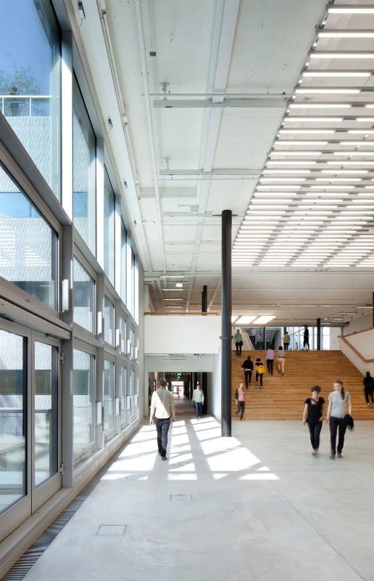
Fig. 1: Illumination of the state-of-the-art university campus is provided by 5500 Zumtobel TECTON luminaires.
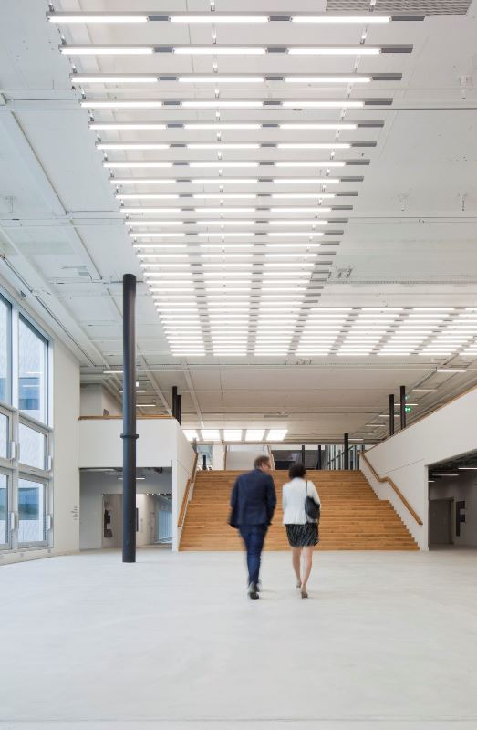
Fig. 2: The design of the campus building picks up the former industrial building's architecture, creating a heterogeneous space where different interests are reconciled.
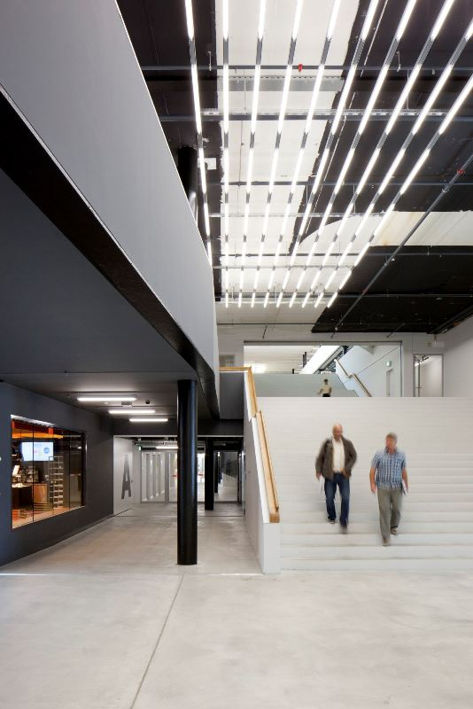
Fig. 3: The aim of the lighting concept is not to produce uniform brightness, but to have the luminaires arranged so as to divide the space into zones and create a dialogue between light and dark.
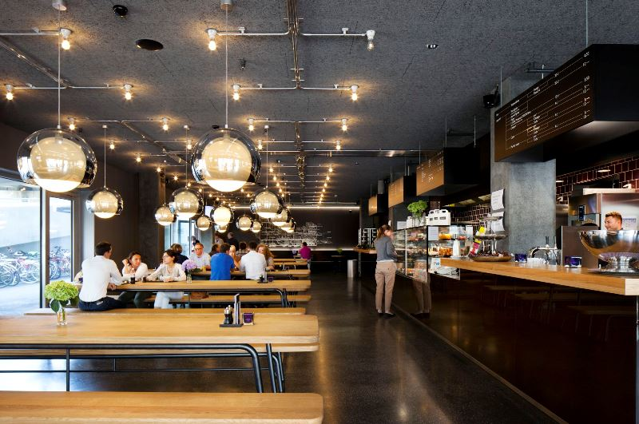
Fig. 4: SCONFINE SFERA pendant luminaires are used in the bistro Chez Toni.
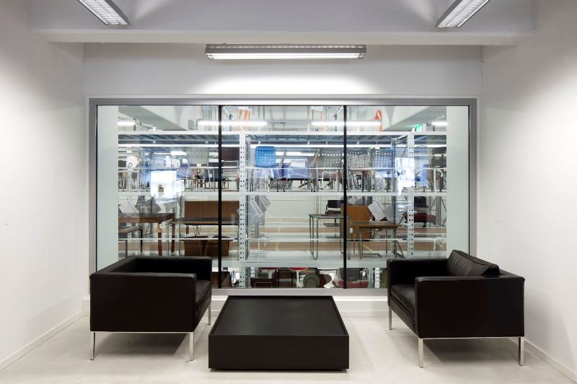
Fig. 5: A special solution including a louvre and aluminium housing was mounted on TECTON trunking.

Press contact:
Zumtobel Lighting GmbH
Sophie Moser
PR Manager
Schweizer Strasse 30
A-6850 Dornbirn

Tel +43-5572-390-26527
Mobil +43-664-80892-3074
E-Mail press@zumtobel.com
www.zumtobel.com

Sales contact:
Zumtobel Lighting Ltd.  Chiltern Park  Chiltern Hill, Chalfont St Peter  Buckinghamshire SL9 9FG  United Kingdom  Tel: +44 1753 482 650  Fax: +44 1753 480 350  uksales@zumtobel.com  www.zumtobel.co.uk | Zumtobel Lighting Inc.  3300 Route 9  Highland , NY 12528  United States  Tel: +1 845 691-6262  Fax: +1 845 691-6289  zli.us@zumtobelgroup.com  www.zumtobel.us

For further contact details in further sales regions please visit: http://www.zumtobel.com/com-en/contact.html

About Zumtobel
Zumtobel, a leading international supplier of integral lighting solutions, enables people to experience the interplay of light and architecture. As a leader in innovation, Zumtobel provides a comprehensive range of high-quality luminaires and lighting management systems for professional interior lighting in the areas of offices, education, presentation & retail, hotel & wellness, health, art & culture as well as industry. Zumtobel is a brand of Zumtobel AG with its head office in Dornbirn, Vorarlberg (Austria).
Zumtobel. The Light.

