Press release

Innovative office lighting meeting users' needs
At Light+Building, Zumtobel presents adaptable lighting solutions that meet people's desire for individuality.

Dornbirn, March 2014 - The most recent study carried out by Zumtobel Research in the field of user research is dedicated to the subject of individual user preferences for the lighting of workstations. In the user study developed together with Fraunhofer IAO it was soon found that most office workers want more influence on the lighting situation, and that they prefer a combination of direct and indirect light. This fundamental application knowledge forms the basis of Zumtobel's user-oriented design process. On the basis of these research findings, Zumtobel has adjusted and extended its product range for office applications.
SEQUENCE – LED luminaire for adaptable lighting at the workstation
With SEQUENCE, Zumtobel launches an LED luminaire in the market that meets the manifold requirements of employees with respect to ideal office lighting as well as the need for individuality to the utmost degree. SEQUENCE offers a perfect combination of direct and indirect lighting and scores high on modules than can be individually controlled. SEQUENCE has been designed as a pendant or surface-mounted luminaire and consists of 8 or, optionally, 14 module units arranged alongside each other, each with 6 x 3 centrally arranged LED light points. The special lens technology in front of each of the 18 central LEDs provides for optimal direction of the task light with simultaneously high glare control, thus preventing annoying reflections on displays. This requires an optical system explicitly matched to LED technology: the transparent lenses ensure a high light output ratio of the system, and accordingly a luminaire efficiency of up to 100 lm/W with a luminous flux level of up to 9000 lm, by reflecting the injected light. At the same time, thanks to an opal cover frame, the 24 outer LEDs provide diffuse ambient light as well as an altogether softer light distribution. Grouped together in three sets, the individual modules and the indirect light component can be controlled individually. Each set has a DALI address. The electronic control system, especially developed for SEQUENCE, ensures gentle transitions between the 14 modules. This makes adaptive lighting possible.
Besides this exceptional performance feature, SEQUENCE boasts an especially slender design that blends perfectly into any interior. SEQUENCE is available with colour temperatures of 3000 K (warm) and 4000 K (intermediate).

LIGHT FIELDS evolution TW – LED luminaire range featuring Tunable White technology
The LIGHT FIELDS evolution Tunable White LED luminaire range complies with the clear and uniform stylistic idiom of the iF design award-winning product range, steering it towards a user-friendly future thanks to profound application know-how and technological innovations. LIGHT FIELDS evolution featuring Tunable White technology is Zumtobel's answer to the users' need, as shown in the course of a Fraunhofer study, for adaptive light that can be customised. Tunable White stands for intelligent adjustment of the colour temperature to changing room situations and room utilisation. The whole luminaire range can be continuously dimmed by the user between warm (3000 K) and cool (6000 K) colour temperatures, allowing for implementation of a perfect lighting situation at the workstation. This is made possible by integrating Tridonic Tunable White LED modules together with a matching converter. Tunable White also allows for adjustment to changes due to the time of day and the season: depending on requirements, the luminaire can be adjusted to match the currently prevailing conditions. At the same time, LIGHT FIELDS evolution Tunable White offers perfect lighting quality without glare, just like the rest of the LED luminaire range. This is made possible by the patented micro-pyramidal optic (MPO+) that prevents annoying reflections on displays. Even at high luminous flux levels, luminance is consistently reduced, providing pleasantly distributed light. In addition, innovative technologies have been incorporated in the various luminaire models. For the recessed, surface-mounted and wall-mounted luminaires, Zumtobel has developed the 3Dprotect® reflector. Its 3D structure protects the LED modules during installation, preventing damage from electrostatic discharge. At the same time, the structure's high reflection factor ensures an increase in the luminaire efficiency level. In the free-standing and pendant luminaires, the dot matrix based on the litePrint® light guide technology ensures uniform light distribution. At the same time, a precisely defined light component is directed upwards in selected areas, via openings in the luminaire housing.

PANOS evolution and PANOS infinity – extended LED downlight ranges
Thanks to excellent lighting quality, high-quality materials, an unclutterd design and innovative technologies, the PANOS range is one of the most efficient and comprehensive LED downlight ranges in the Zumtobel product portfolio. The new PANOS evolution LED range combines the familiar benefits of the PANOS family with efficient high-output LED modules featuring a colour rendering index of Ra > 80. The new range is available in a round and a square version. Additionally, customers may choose from three lumen packages of 1000, 1800 or 2400 lm, with alternative colour temperatures of 3000 K or 4000 K.
Moreover, the successful PANOS infinity and PANOS evolution ranges are extended to form a global range, and are specified for different markets all over the world. In a first stage, both round and square versions of the downlights are available in various colour temperatures of 2700 K to 4000 K.

AXON – direct/indirect pendant LED luminaire
With a cross-section of 38 mm x 38 mm, the slimline AXON pendant luminaire is designed for contemporary office architecture, and it also impresses through excellent lighting quality. Thanks to the combination of high-output LEDs and the latest LED lens technology, the light is optimally directed and at the same time perfectly glare-free. Additionally, the perfect balance between indirect and direct light distribution provides for a pleasant atmosphere at the workstation. For individual adjustment to user requirements, AXON is available in different versions and with a colour temperature of either 3000 K or 4000 K.

SFERA – free-standing LED luminaire featuring swarmControl technology
Open-plan layouts are common in today's offices. The SFERA free-standing luminaire supports individual visual needs of employees in an office environment and enhances a sense of well-being at the workplace with a high luminous flux level of over 11,500 lm and innovative technologies. This includes the sensControl presence detector that switches the luminaire on or off depending on whether anyone is present at the workstation. A brightness sensor additionally measures illuminance on the desk and dims the luminaire according to the ambient lighting conditions. Additionally, innovative swarmControl technology allows for quick and simple adjustment to changing room situations, by means of the corridor function and presence detection. The former primarily provides for safety and orientation: by means of a presence detector the luminaires are dimmed up one after the other, indicating the way to the workstation. The presence-based function, on the other hand, ensures ideal lighting conditions at the workplace, with the light quantity being adjustable at any time. SFERA communicates with neighbouring luminaires and forms a light cloud around the workstation.

Captions:
(Photo credits: Zumtobel)
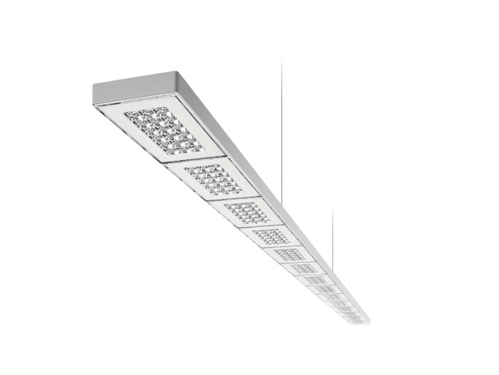
Caption 1: SEQUENCE provides a perfect combination of direct and indirect lighting and scores high on modules than can be individually controlled.

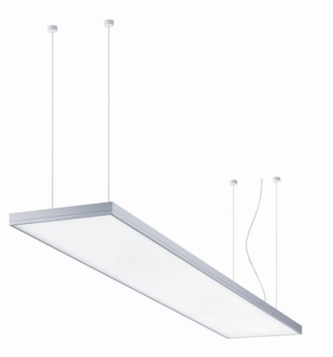
Caption 2: The LIGHT FIELDS evolution LED luminaire featuring TunableWhite technology is Zumtobel's answer to the users' need for adaptive light that can be customised.

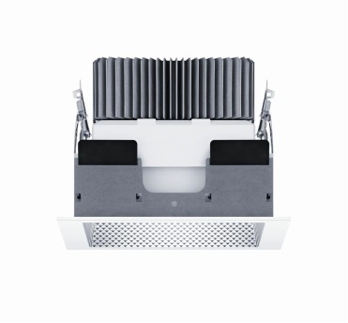
Caption 3: Thanks to excellent lighting quality, high-quality materials, an uncluttered design and innovative technologies, the PANOS range is one of the most efficient and comprehensive LED downlight ranges in the Zumtobel product portfolio.

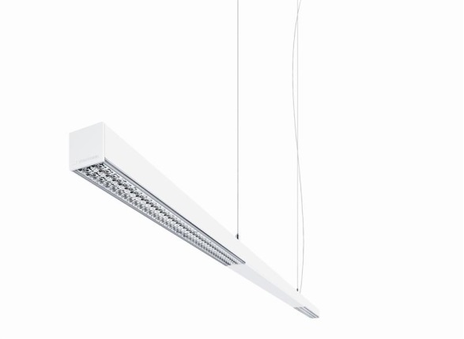
Caption 4: With a cross-section of 38 mm x 38 mm, the slimline AXON pendant luminaire is designed for contemporary office architecture, and is also impressive on account of its excellent lighting quality.

Caption 5: SFERA supports individual visual needs and enhances people's sense of well-being at the workstation with a high luminous flux level of over 11,500 lm and innovative technologies.

Press contact:
Zumtobel Lighting GmbH  Sophie Moser  PR Manager  Schweizer Strasse 30  A-6851 Dornbirn  Phone +43-5572-390-26527  Mobile +43-664-80892-3074  Email sophie.moser@zumtobelgroup.com  www.zumtobel.com | Zumtobel Lighting GmbH  Nikolaus Johannson  Head of Brand Communication  Schweizer Strasse 30  A-6851 Dornbirn  Phone +43-5572-390-26427  Mobile +43-664-80892-3202  Email nikolaus.johannson@zumtobelgroup.com  www.zumtobel.com

About Zumtobel
Zumtobel, a leading international supplier of integral lighting solutions, enables people to experience the interplay of light and architecture. As a leader in innovation, Zumtobel provides a comprehensive range of high-quality luminaires and lighting management systems for professional interior lighting in the areas of offices, education, retail, hotel & wellness, health, art & culture as well as industry. Zumtobel is a brand of Zumtobel AG with its head office in Dornbirn, Vorarlberg (Austria).
Zumtobel. The Light.

Please find further information on the study "The Light. Global User Study on Lighting Quality Perceived in Offices" in the Zumtobel press folder. The study can be found on the Internet at http://www.zumtobel.web-erhebung.de/.

