Press release

Two projects representing Zumtobel at Luminale 2014

Dornbirn, March 2014 – The Luminale festival is the Biennale of Lighting Culture and will be held already for the seventh time concurrently with light+building, the international architecture show, from 30 March to 4 April 2014 in Frankfurt am Main. This year, even two projects will be presented that create lighting experiences supported by Zumtobel.
Cornea Ti – morphing light to space
Cornea Ti, the lighting installation created by students of the bachelor degree programme in interior design at the University of Applied Sciences in Mainz, will be located on a container boat near Untermainbrücke. In a world of data encryption and encoding, the installation visualises illusion and reality of a message, creating a bridge into our information age.
At twilight, 1600 video-compatible Capix LED façade luminaires by Zumtobel turn the installation to life, ensuring an interactive spatial experience for visitors. The secret of Cornea Ti is an anagram – a new word is produced by rearranging its letters. While visitors walk through the installation, the transformed letters will produce a word the real meaning of which has to be deciphered.
In the process, the LED pixels are individually controlled in real time via a PC and animated as a system responding to movement in the space. In this way, visitors are accompanied by interactive light on their way through a world of letters, creating a personal experience of space. The lighting installation is accompanied by music. Every night, live concerts will be held in collaboration with musicians from HfMDK Frankfurt and Ensemble Modern, indulging visitors in a unique light and sound installation.
For more information, please visit http://luminale.fh-mainz.de
Twinkle Twinkle
A second installation sponsored by Zumtobel can be found on the square in front of the Deutsche Bank Towers. Consisting of 576 prism poles made of glass, the Twinkle Twinkle installation is a transparent and dynamic structure that reflects daylight and its surroundings, creating an enthralling experience for visitors. Daylight is refracted by the prism poles, which produce lighting-like reflections fanning out into a fascinating colour spectrum.
In daylight, the sculpture appears scarcely palpable; at night, 18 Elevo RGB DMX façade luminaires set the four-metre concentric structure aglow. The special lighting presentation creates a dramatic effect, which is enhanced by background music. Twinkle Twinkle is a project by Glasbau-Hahn GmbH, NE-AR Nixdorff Etchegorry – Architecture Research, lichtundsoehne – lighting & visual design, O-S-D – office for structural design and studioheyhey – visual communication.

At this year's light+building, Zumtobel – as an expert in the field of interior lighting for commercial purposes – will also present an extensive product range for façade & architecture applications. Providing smart, resource-conserving illumination for façades based on cutting-edge LED technology, Zumtobel meets both functional and aesthetic requirements.

Addresses:
Cornea Ti : container boat on the bank of the Main (historic city side, Untermainbrücke)
Free entrance from 7 p.m. / food and drinks available on board
“Visual Music” performance: 6 – 7 p.m. / admission fee: EUR 15

Twinkle Twinkle: Taunusanlage 12 / German Bank Towers
Lighting installation switched on at nightfall

Captions: (Copyright Zumtobel)

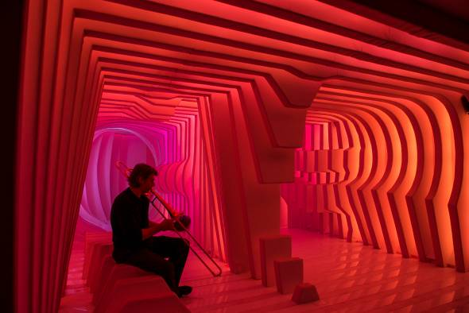
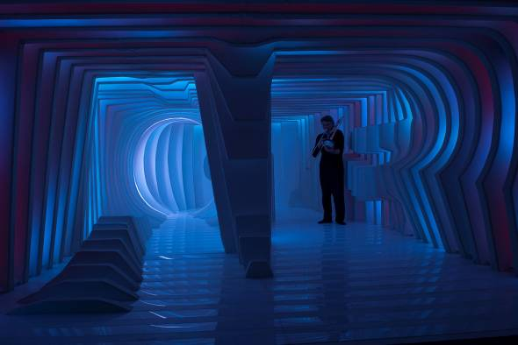
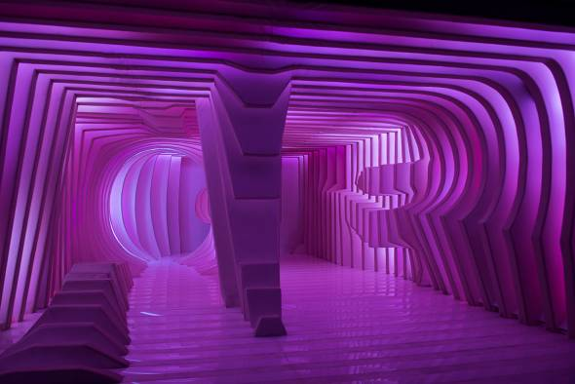

Caption 1-3: 1600 video-compatible Capix LED luminaires by Zumtobel turn the Cornea Ti installation at the Luminale to life, creating an interactive spatial experience for visitors.

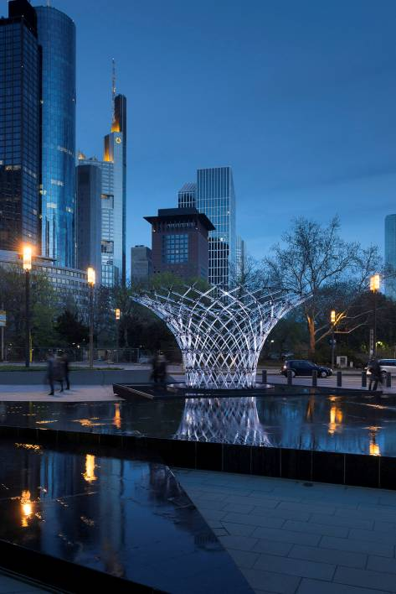
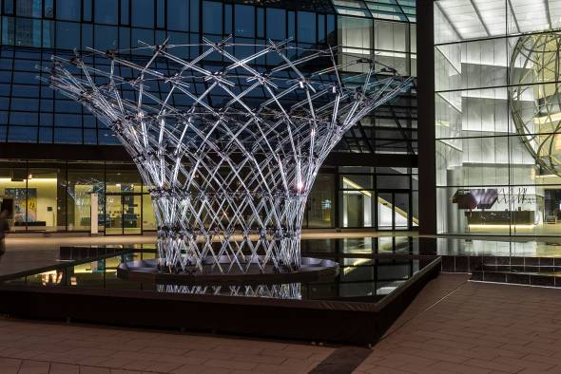

Caption 4-5: The Twinkle structure symbolises transparency and communication. Light is transmitted and transformed by 576 unique glass poles radially arranged to create a dynamic spatial system.

Press contact:
Zumtobel Lighting GmbH
Sophie Moser
PR Manager
Schweizer Strasse 30
A-6851 Dornbirn

Tel +43-5572-390-26527
Mobile +43-664-80892-3074
E-mail sophie.moser@zumtobel.com

www.zumtobel.com
Sales Germany, Austria, Switzerland
Zumtobel Licht GmbH  Grevenmarschstr. 74-78  32657 Lemgo  Germany  Tel +49-5261-212-7445  Fax: +49-5261-212-817445  E-mail: info@zumtobel.de  www.zumtobel.de | Zumtobel Licht GmbH  Donau-City-Strasse 1  1220 Vienna  Austria  Tel.: +43-1-258-2601-0  Fax: +43-1-258-2601-82845  E-mail: welcome@zumtobel.at  www.zumtobel.at
Zumtobel Licht AG
Thurgauerstrasse 39
8050 Zurich
Switzerland
Tel.: +41-44-30535-35
Fax: +41 44 305 35 36
E-mail: info@zumtobel.ch
www.zumtobel.ch

About Zumtobel
Zumtobel, a leading international supplier of integral lighting solutions, enables people to experience the interplay of light and architecture. As a leader in innovation, Zumtobel provides a comprehensive range of high-quality luminaires and lighting management systems for professional interior lighting in the areas of offices, education, retail, hotel & wellness, health, art & culture as well as industry. Zumtobel is a brand of Zumtobel AG with its head office in Dornbirn, Vorarlberg (Austria).
Zumtobel. The Light.

