Press release

Zumtobel wins “Red Dot Award” 2013 for image film
Dornbirn, October 2013 – Zumtobel has received a “Red Dot Award: Communication Design” 2013 for its creative image film. The film titled “Your light in a world of change” was created in collaboration with the Boros agency and the Zeitsprung Commercial film production company. The 1:30-minute film is an impressive and emotional story of how Zumtobel seeks to provide perfect lighting quality for people while protecting the environment. “Zumtobel stands for a new quality of light: the design-oriented lighting solutions we provide originate from our vision – to create the best possible light for people and the environment. We want to use light to make work easier, create worlds of experience and improve communications and safety. The film communicates this message very successfully,” says Stefan von Terzi, Director Marketing Zumtobel, who is very pleased about the award.
The plot revolves around the modern urban individual of the 21st century and the role light plays in people's everyday life. Live footage cleverly combined with 3D animations shows how lighting solutions adjust to the respective situation and people's needs in a world of change. The audience follows a man on his way through everyday life, witnessing how light makes living and working easier, enhancing his sense of well-being while increasing the energy efficiency of buildings.
“A good image film not only communicates the messages of a brand but addresses the target group and its needs in every detail. Our corporate production for Zumtobel is a perfect example of a film that credibly and emotionally communicates how a company uses innovative technology to improve the modern individual's quality of life,” says Christian Boros, CEO and Creative Director of the Boros agency, explaining the concept behind the film.
Zumtobel's image film also managed to win this year's “intermedia-globe Gold Award” and “German Design Award Special Mention” prizes.
Red Dot Award
The “Red Dot Award: Communication Design” is a renowned communication design competition. This year, a total of 6812 entries from 49 countries were submitted. Members of the international jury included Taiwanese designer Aaron Nieh, Turkish art director Ali Bati and Scottish designer Jack Renwick, among others. The key evaluation criteria of the entries submitted included originality and emotional quality as well as appropriate addressing of the target group, quality of design, recognition value and relevance for society. On 18 October 2013, the prizes were awarded at a ceremony in the Berlin Concert Hall attended by some 1400 guests from all over the world. The “Red Dot” prize-winning projects will be published in the International Yearbook Communication Design 2013/2014 and displayed at an online exhibition. Moreover, the “Red Dot” has become established as a coveted international quality mark.
On BOROS:
The BOROS agency was established in 1990 by Christian Boros. Employing a team of 49 people including designers, web designers, business economists, political scientist, communications experts and German philologists, BOROS develops interdisciplinary communication solutions many of which have received international awards.
Responsible for production:
Zumtobel Lighting GmbH, Dornbirn (client): | Stefan von Terzi, Director Marketing Zumtobel  Martin Finkman, project management
Boros GmbH, Wuppertal (idea) | Christian Boros, CEO & Creative Director  Martina Schiffer-Gottfried, Project Manager  Guido Halfmann, Copy
Zeitsprung Commercial GmbH, Cologne (film production): | Oriol Puig & Reto Caffi (Director)  Selim Sevinc, Executive Producer  Ralf M. Mendle, D.o.P.  Sabine Schwedhelm, casting
Tracks & Fields (music) | Erik and Vera Ohl
Trizz, Barcelona  (visual effects and 2D & 3D design) | Christopher Vulpi, Executive Producer

Film and pictures:

(Credits: Zumtobel)

http://www.zumtobel.com/video

Image 1:

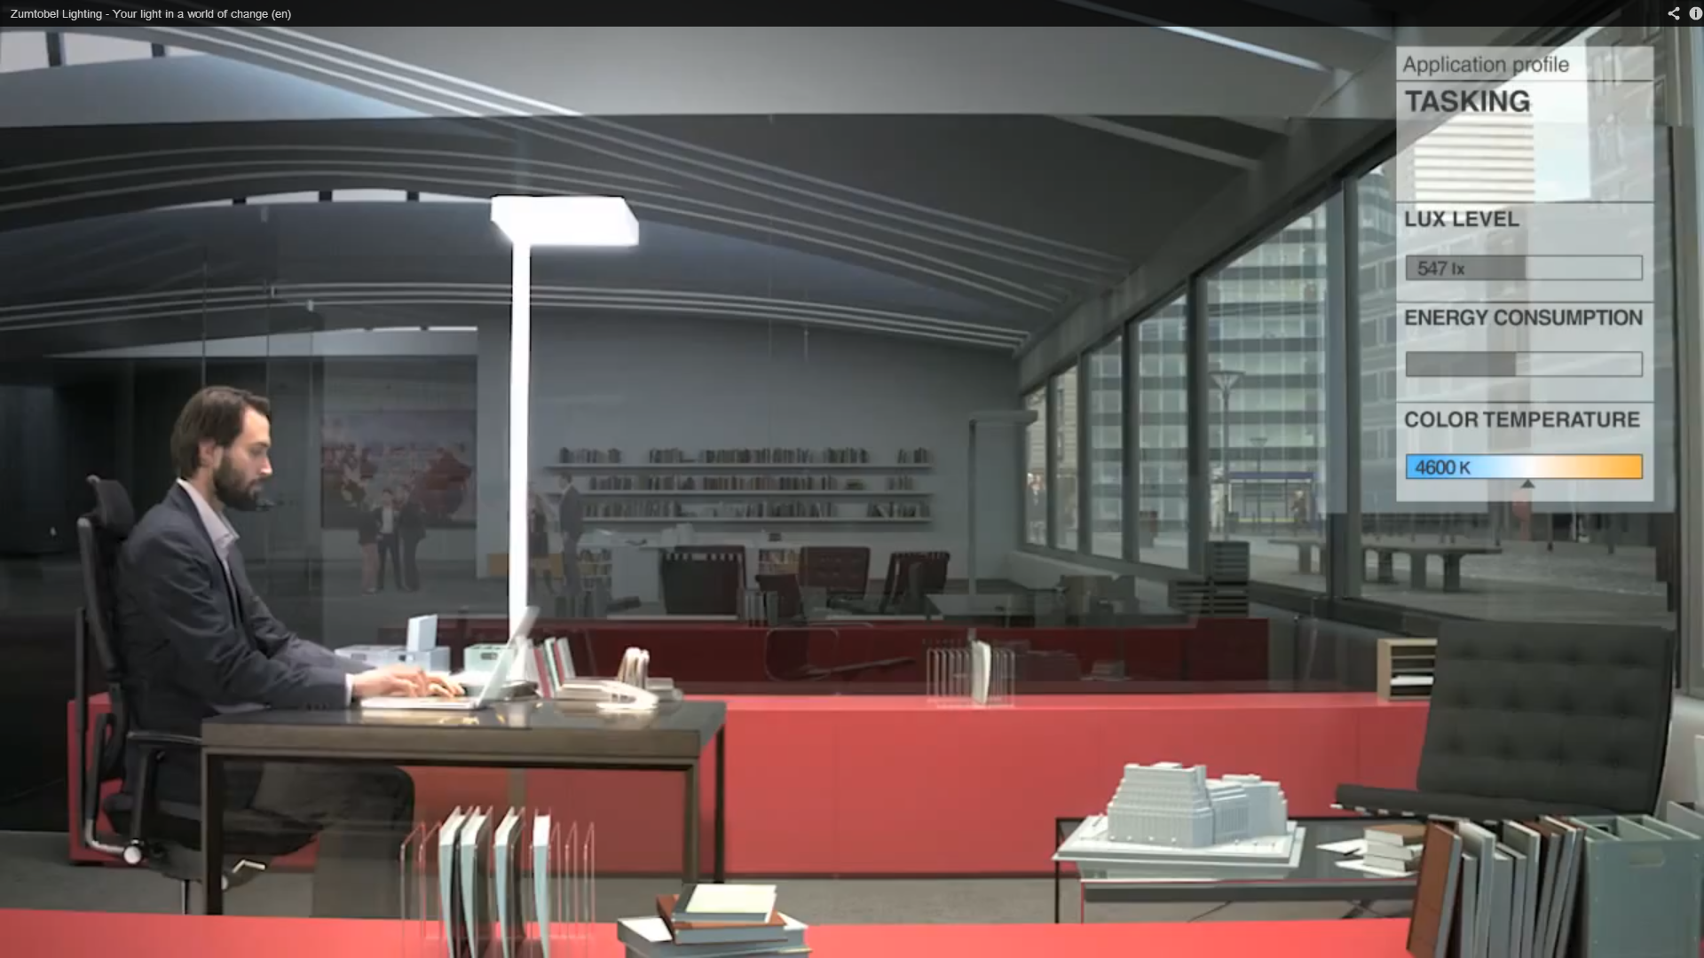

Image 2:

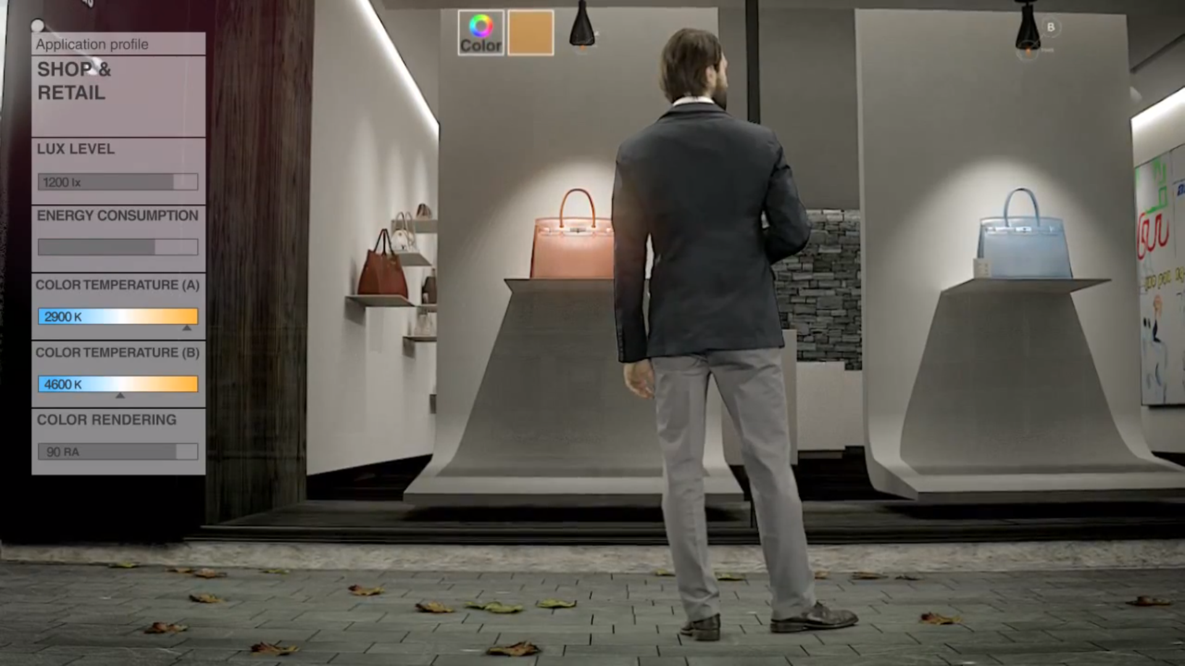

Image 3:

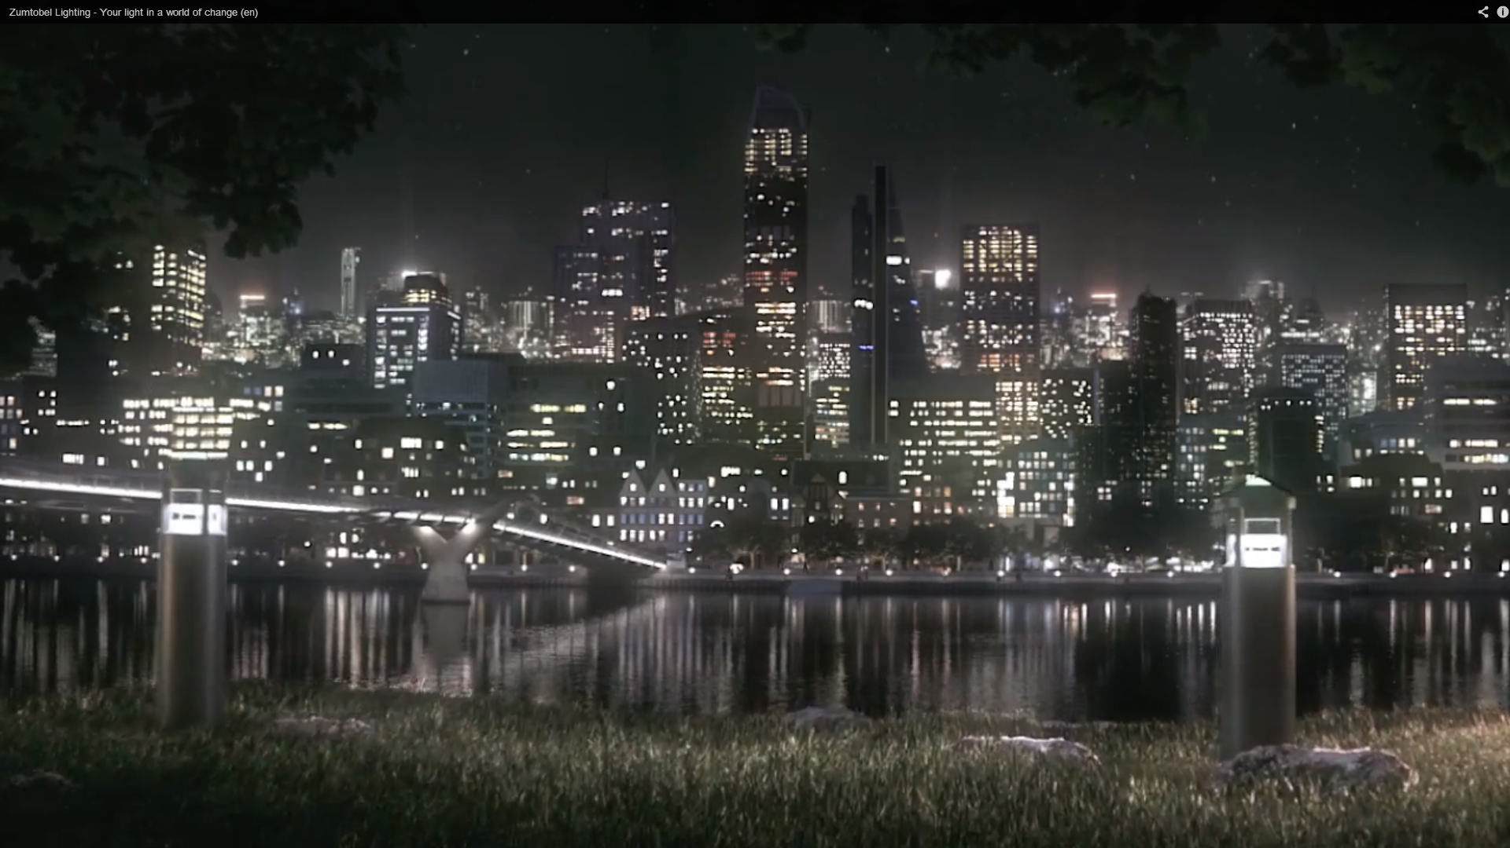

Image 4: Official logo of the “Red Dot Design Award” for 2013
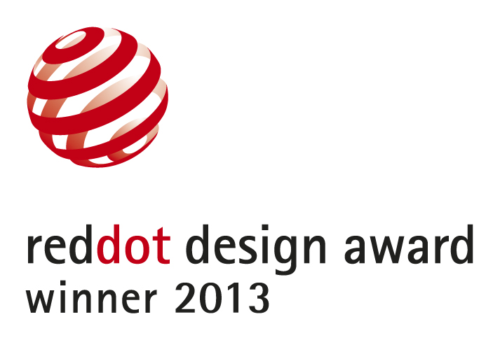

Press contact:
Zumtobel Lighting GmbH
Sophie Moser
PR Manager
Schweizer Strasse 30
A-6851 Dornbirn

Tel. +43-5572-390-26527
Mobile +43-664-80892-3074
E-mail sophie.moser@zumtobel.com

www.zumtobel.com
Sales Germany, Austria, Switzerland
Zumtobel Licht GmbH  Grevenmarschstr. 74-78  32657 Lemgo  Germany  Tel.: +49-5261-212-7445  Fax: +49-5261-212-817445  E-mail: info@zumtobel.de  www.zumtobel.de | Zumtobel Licht GmbH  Donau-City-Strasse 1  1220 Vienna  Austria  Tel.: +43-1-258-2601-0  Fax: +43-1-258-2601-82845  E-mail : welcome@zumtobel.at  www.zumtobel.at
Zumtobel Licht AG
Thurgauerstrasse 39
8050 Zurich
Switzerland
Tel.: +41-44-30535-35
Fax: +41 44 305 35 36
E-mail: info@zumtobel.ch
www.zumtobel.ch

About Zumtobel
Zumtobel, a leading international supplier of integral lighting solutions, enables people to experience the interplay of light and architecture. As a leader in innovation, Zumtobel provides a comprehensive range of high-quality luminaires and lighting management systems for professional interior lighting in the areas of offices, education, presentation & retail, hotel & wellness, health, art & culture as well as industry. Zumtobel is a brand of Zumtobel AG with its head office in Dornbirn, Vorarlberg (Austria).
Zumtobel. The Light.

