Press release
Dornbirn, April 2012

Brightly lit garden halls
Extension to the Städel Museum in Frankfurt

The lighting concept was crucially important for the subterranean extension to the Städel Museum in Frankfurt. Zumtobel realised a tailor-made custom lighting solution together with architects schneider+schumacher and lighting designers from LichtKunstLicht. This solution meets the very highest requirements from a conservator's viewpoint and ensures that light is an integral part of the architecture.

The new extension provides approximately 3000 m² of exhibition space underneath the garden of the existing building. The exhibition hall is up to 8.2 m high and is spanned by an elegantly curved, seemingly weightless ceiling. Although it is an underground structure, the new extension is apparent on the surface. Visitors can walk over the museum's slightly domed garden, which is now covered by a grid of circular skylights that are used to let light filter into the new exhibition hall below.

These 195 skylights with diameters of 1.5 m to 2.5 m form openings in the self-supporting, slightly domed ceiling of the subterranean hall. They allow daylight to enter the exhibition space below and are also used as an artificial light source with a ring of LED elements that is fitted with warm (2700 K) and cool white (5000 K) LEDs - this is a custom solution developed by Zumtobel in cooperation with LichtKunstLicht lighting designers and schneider+schumacher architects. When it is cloudy, and in the evening and at night, these LEDs ensure that paintings and exhibits are uniformly illuminated.

"The mix of ambitious lighting quality, light distribution and colour rendering combined with the brief to integrate the lighting into the architecture invisibly from a conservator's viewpoint was a challenge and spurred me and my team on" says Reinhardt Wurzer, Zumtobel Lighting's International Projects Manager. "Our task was to meet these complex requirements with an integral lighting solution. It was our ability to develop tailor-made solutions and our partnership-based cooperation with the lighting designers and architects that enabled us to develop this custom LED lighting solution. By combining an intelligent control system with cutting-edge LED technology, we managed to devise a totally individual, adaptable lighting concept that delivers perfect lighting at all times and removes any obstacle to art appreciation."

LichtKunstLicht's CEO Andreas Schulz is also pleased with the result: "Achieving this success called for unimpeded, critical and occasionally passionate communication between manufacturer and designer. The outstanding result demonstrates how effective communication was."

The entire garden hall is divided up by partitions into smaller, closet-like exhibition spaces. Specific skylights can be assigned to the spaces thus created, thereby making it possible to adjustt lighting conditions in a highly selective way. Thanks to Zumtobel's tailor-made lighting solution, highly sensitive exhibits such as works on paper, for instance, can be displayed directly alongside another space with lighting for sculptures. Illuminance levels can be individually adapted for each skylight as needed. Custom-built Arcos projection spotlights with various optics can be plugged into sockets in the skylights in order to emphasise individual objects or pick out wall surfaces as required. The skylights have a sealed downward diffuser foil system in order to ensure a uniform lighting look.

The client opted to use Zumtobel'sLuxmate Professional lighting control range to ensure rational use of daylight: the lighting management system controls the use of artificial light from the skylights depending on the amount of available daylight and the specified required or maximum lighting levels for the exhibits that are on display. To achieve this, a daylight sensor installed on the roof of the museum building monitors the prevailing outdoor brightness and relays relevant data to the lighting management system, which controls the luminaires accordingly. Using partitions to divide up the hall space is no problem for the lighting control system. The skylights assigned to a particular area are uniformly controlled by forming virtual spaces.

Every skylight incorporates a movable light shielding system in the form of roller blinds in order to protect exhibits against excessive light. This system makes it possible to reduce the amount of daylight entering the hall in four stages right down to complete darkness. The roller blinds are integrated in the lighting control system and are moved to their predefined position depending on the position of the sun and on outdoor brightness. Additional built-in light sensors alert the operator to control system anomalies, e.g. foliage obstructing a skylight. This ensures ideal lighting conditions at all times and makes sure that visitors enjoy the art on show to the fullest possible extent.

Zumtobel.The Light.

Fact box:
Client: Städelsches Kunstinstitut, Frankfurt on Main/D
Architects for the extension and refurbishment of the existing building: schneider+schumacher, Frankfurt on Main /D
Lighting design: Licht Kunst Licht AG, Bonn/Berlin/D
Electrical consultants: Delta-Tech, Weiterstadt/D
Electrical installations: Imtech, Rüsselsheim/D
Lighting solution in new building: LED special solution for the circular skylights, special solution ARCOS LED spotlight, LUXMATE Professional lighting control system

Brief profile
Zumtobel is a leading international supplier of integral lighting solutions that enable people to experience the interplay of light and architecture. As a leader in innovation, the luminaire manufacturer provides a comprehensive range of high-quality luminaires and lighting management systems for the most varied application areas of professional interior lighting – including offices and educational facilities, presentation and retail, hotels and wellness, health and care, art and culture as well as industry and engineering. Zumtobel is a brand of the Zumtobel group with its head office in Dornbirn, Vorarlberg (Austria).

For more information, please contact:

Zumtobel Lighting GmbH Zumtobel Lighting GmbH
NikolausJohannson Nadja Frank
Head of Brand Communication PR Manager
Schweizer Strasse 30 Schweizer Strasse 30
A-6850 Dornbirn A-6850 Dornbirn

Tel. +43-5572-390-26427 Tel. +43-5572-390-1303
Fax.+43-5572-390-926427 Fax.+43-5572-390-91303
nikolaus.johannson@zumtobel.com nadja.frank@zumtobel.com
www.zumtobel.com www.zumtobel.com

Captions:
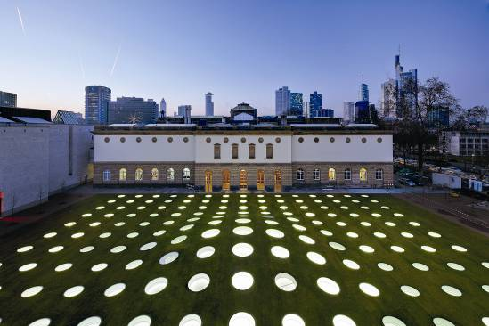

Caption 1: One hundred and ninety five circular skylights allow daylight to flood into the garden halls and transformthe garden into a gleaming carpet of light at night.

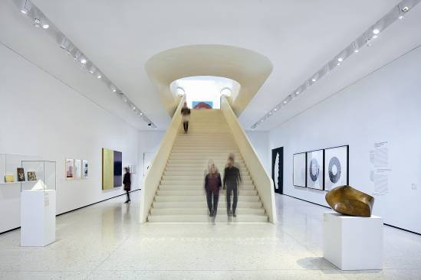

Caption 2: The new exhibition spaces are accessed via a sculptural staircase leading from the main entrance. Cutting-edge LED spotlights welcome visitors and direct their attention straight to the precious exhibits.

According to copyright law, the publication of indoor photos is only admissible with the consent of the competent collecting society for visual arts.

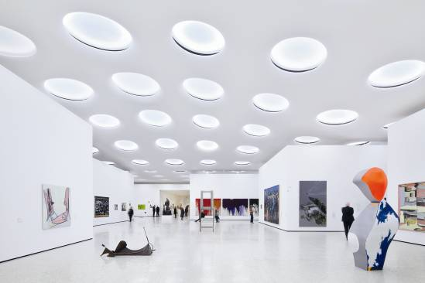

Caption 3: Providing the facility to divide the new garden halls into smaller, closet-like exhibition spaces each with its own lighting posed a major challenge to the lighting designers.

According to copyright law, the publication of indoor photos is only admissible with the consent of the competent collecting society for visual arts.

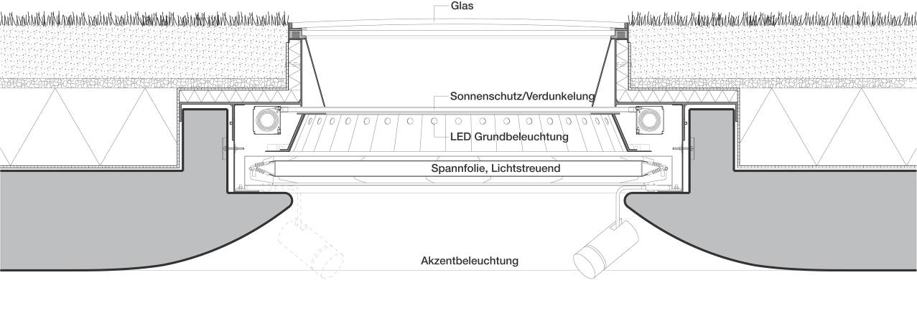

Caption 4: Cross-sectional view of a skylight with Arcos LED spotlights
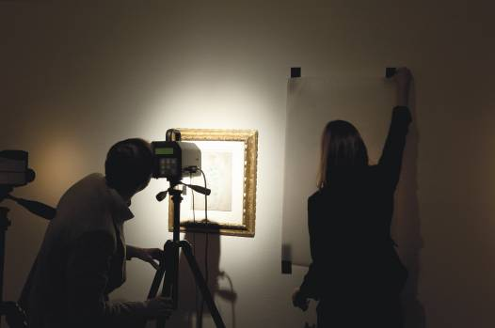

Caption 5: A study set up and conducted by Zumtobel in association with Darmstadt University of Technology yielded new findings which confirm that LED lighting solutions used to illuminate works of art have relatively low damage potential. The results of this study are summarised in a technical article on LED lighting in art and cultural establishments. This study and the technical article can be obtained from: press@zumtobel.com.

Photo credits: Zumtobel, © VBK Vienna 2012

