Press release
Dornbirn, May 2012

And the winner is…
Rookery Building in Chicago wins 2012 WAN award

The Rookery Building in Chicago, which has recently been fitted with a new façade lighting solution by Zumtobel, is the winner of the 2012 WAN (World Architecture News) Award.

The façade illumination of the Rookery Building in Chicago developed by the New York lighting design studio Office for Visual Interaction (OVI) and implemented by Zumtobel was awarded a prize as the best lighting solution. Because it is architecturally unique, the office building has been listed in the National Register of Historic Places since 1970. It is not just its interior, designed by Frank Lloyd Wright, that hides unique, fascinating architectural features. The façade of the high-rise, which is decorated with ornate stucco, is another aspect of this architectural jewel. The innovative and now prize-winning lighting system illuminating the building's unique masonry allows the Rookery to develop an elegant, low-key identity.

The custom LED luminaire specially manufactured by Zumtobel for this project boasts a special optic and a colour temperature of 3,000 K, which highlights the fine stucco work to perfection. A project-specifically adapted optic adjusts the typical, rotationally symmetrical cone of light produced by the LED point light sources to produce flat, elliptical light distribution. This tailor-made solution – the result of selective light distribution observations and intensive testing – makes it possible to distribute light precisely across three floors.

“Zumtobel was able to harness its technical experience effectively to suit our project. The selective use of miniature LED lighting opens up completely novel façade design possibilities. The high-precision optics minimise light pollution and ensure minimum energy consumption,” the OVI team speaks highly of the successful collaboration. The special luminaires are mounted on holders attached to the window frames in order to minimise light pollution, which might otherwise damage the fragile natural stone, and to comply with exacting requirements intended to protect historic buildings and monuments. The light sources, in conformity with applicable regulations, cannot be seen from the road below. In the evening, the Rookery is a breathtaking symbol of timelessness and has become a new highlight of Chicago's financial district.

Each year, the architectural portal World Architecture News (http://www.worldarchitecturenews.com) awards the homonymous awards to architectural projects featuring innovative lighting solutions in which state-of-the-art technology is combined with outstanding design.

Zumtobel. The Light.

Brief profile
Zumtobel is a leading international supplier of integral lighting solutions that enable people to experience the interplay of light and architecture. As a leader in innovation, the luminaire manufacturer provides a comprehensive range of high-quality luminaires and lighting management systems for the most varied application areas of professional interior lighting – including offices and educational facilities, presentation and retail, hotels and wellness, health and care, art and culture as well as industry and engineering. Zumtobel is a brand of the Zumtobel group with its head office in Dornbirn, Vorarlberg (Austria).

For more information, please contact:

Zumtobel Lighting GmbH Zumtobel Lighting GmbH
Nikolaus Johannson Nadja Frank
Head of Brand Communication PR Manager
Schweizer Strasse 30 Schweizer Strasse 30
A-6850 Dornbirn A-6850 Dornbirn

Tel. +43-5572-390-26427 Tel. +43-5572-390-1303
Fax +43-5572-390-926427 Fax +43-5572-390-91303
nikolaus.johannson@zumtobel.com nadja.frank@zumtobel.com
www.zumtobel.com www.zumtobel.com

Credits: Zumtobel

B1:
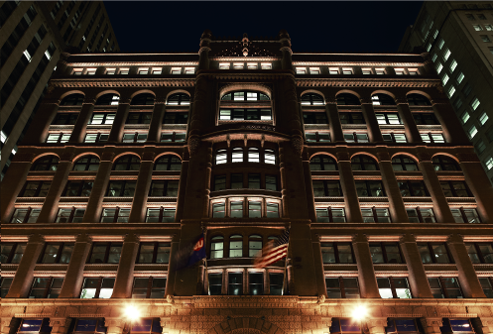

B2:
