Press release
Dornbirn, November 2011

History brought alive
Zumtobel is transforming the Military History Museum into a place that brings history to life

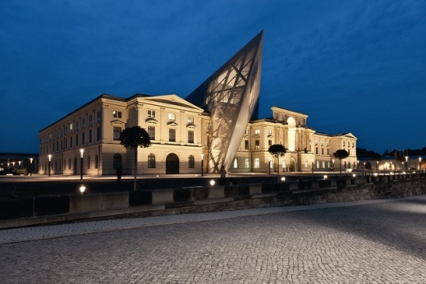
With the reopening of the Military History Museum in Dresden in October 2011, museum managers dared to tackle a highly controversial topic: staging a show that highlights war and the use of armed force. This aim has been successfully accomplished – not least thanks to a combination of cutting-edge architecture, subtle lighting compositions and the concept behind the museum's content. Visitors are guided through a world where there is no glorification of war and abundant space for reflection. Star architect Daniel Libeskind devised an extraordinary architectural design for this venture which is bolstered by a comprehensive Zumtobel lighting concept. This combination of architecture and lighting transforms the exhibition spaces into a fascinating journey through time and provides a fresh way of viewing this type of museum.

An exhibition that covers over 100 years of momentous history
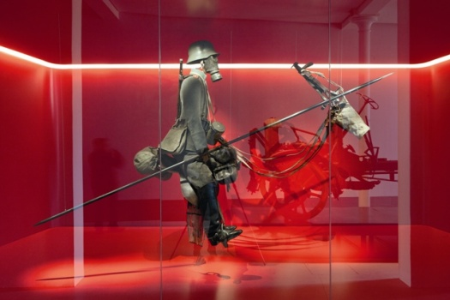
With an exhibition area of 13,000 m2, the Military Museum is the largest military history museum in Germany, providing a compelling retrospective of more than 100 years of chequered history. Reconciling the old and the new and achieving closure with the past, this was the challenge that the architecture and the lighting concept had to face up to. This contemporary redesign marks a break with the past. This is evidenced by the wedge-shaped design of the new extension which cuts through the previous building's classical structural order. Despite its jarring form, it unites the history of the town with its present-day life. The new extension not only alters the external appearance of the building, it also modifies the spatial structures of its interior. Inside the museum, a journey based on thematic considerations awaits visitors in the new extension while history is presented in chronological order in the old building. The thematic trail depicts crucial experiences and events in relation to war and armed force from various epochs. The chronological presentation weaves a historical thread from the late Middle Ages through to the present. A sequence of classic exhibition elements and interactive experiences add variety to the various spaces. People are the main focus and starting point for the museum concept and they are actively involved and encouraged to reflect on the past.

The interplay of light and space
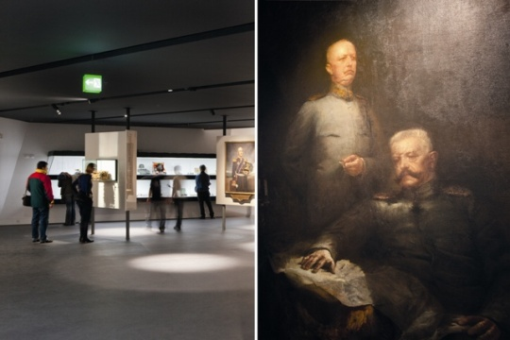
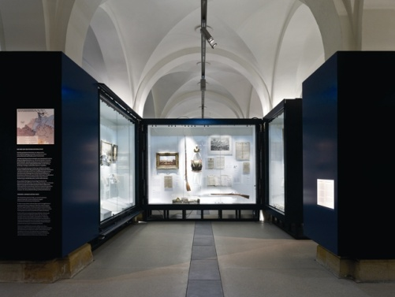
The atmospheric impression that the rooms make on visitors results from the special lighting design which Zumtobel developed in cooperation with Daniel Libeskind. The star architect sees light as a design tool and his sensitive understanding of light it is very evident here. The wide variety of exhibits and materials demanded a flexible lighting design. Sumptuous uniforms, military equipment, small arms and weapons and even evacuation plans – each individual item needed to be shown in a particular light. Ambient lighting and accent lighting merge into each other in a manner that seems completely natural. The spotlights used for the ambient lighting brighten up items that are intended to attract the onlooker's attention and punctuate those areas where detailed visual scrutiny is required. This versatility is provided by Zumtobel's Arcos spotlight system which was specially developed to meet needs in art and culture application areas. The extensive product range offers a suitable product solution for each and every lighting design task. Spotlights can be positioned flexibly on the Tecton trunking system. This 11-pole trunking makes it possible to cater flexibly for the various room lengths and exhibition concepts that are encountered in the museum. The Arcos spotlight system allows the use of HIT metal halide lamps, low-voltage lamps and even LED versions which can either illuminate spaces uniformly or provide deliberately selective accent lighting. Despite being located close to museum exhibits, low thermal radiation ensures gentle lighting. Colour correction filters are used in cases where colours or material properties make this necessary. At the same time, because of their discreet stylistic idiom, the luminaires remain unobtrusive. The same applies to the mandatory emergency lighting. Emergency lighting remains invisible during the day-to-day operation of the museum because the ultra-modern Resclite LED luminaires are seamlessly integrated with the Tecton trunking system. These efficient LED luminaires have a recognition range of 16 m and ensure safe guidance in the event of an emergency.

Authentic lighting emphasises details
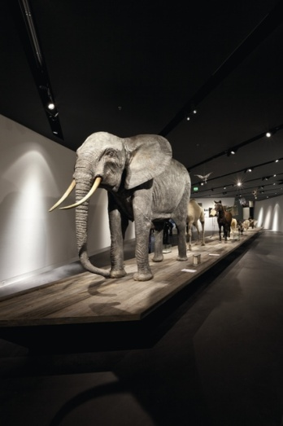
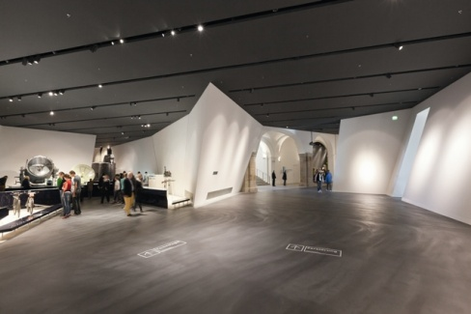
The Zumtobel lighting concept blends into the museum concept harmoniously: on the one hand, it distances visitors from the museum exhibits to a certain extent. On the other hand, the lighting accentuates every detail authentically, as enthralled visitors can see in the various display cabinets. Every medal and every weapon is set off in a nuanced manner. The Starflex optical fibre technology used allows UV-free, heat-free pinpoint lighting that lends the exhibits a thrilling authenticity. The catwalk, a space in which, among other items, life-size model animals are on show, provides a similarly involving backdrop: the result is an atmosphere with a highly lifelike effect that gives onlookers a glimpse of long-ago events.The Arcos spotlights used here have tightly focused beam patterns which produce lighting cones that accurately direct the viewer's gaze and conjure up an exciting mix of light and shadow.

Cleverly accomplished centre-stage settings
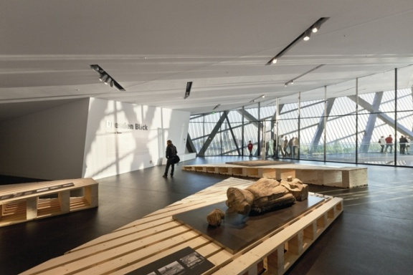
The 11-pole Tecton system is fitted in an aluminium H-section and channel section. The entire system takes care of 3-phase AC power supply, DALI lighting control and includes LED emergency lighting as well as escape route lighting. This modular design provides a perfect way of designing a lighting concept that is consistent in terms of form but delivers different lighting levels. Zumtobel used the Arcos spotlight system to provide both ambient and accent lighting. This sophisticated product range features various sizes and beam angles as well as an extensive range of accessories which ensures that special requirements can always be met using the same product design. Even the acoustic system and surveillance technology were fully integrated into the spotlight housing. This ensures that the ceiling look remains absolutely uncluttered. Special optical fibre lighting outlets with different beam patterns and UV/IR blocking filters were used to illuminate the display cabinets. A Starflex light engine with a 100 W QR-CB halogen lamp with a dichroic glass reflector for optimum injection of light was fitted in line with the customer's requirements. Zumtobel'sLinaria batten luminaire is used to light the special table showcases. Installed flush with the top on the rear wall, this narrow light line does not interfere with the showcase's visual look and illuminates its interior uniformly and pleasantly.

All in all, Zumtobel's lighting scenarios provide the perfect accompaniment to a stroll through the Military History Museum in Dresden. The lighting carries visitors away on a journey through time and the nuanced way that it emphasises each individual element creates a lifelike setting that is conducive to contemplation and reflection.

Zumtobel. The Light

Fact box: Military History Museum, Dresden
Fact box: Military History Museum, Dresden
Client:StaatsbetriebSächs. Immobilien- und Baumanagement, Dresden/D
Architects: StudioDaniel Libeskind AG, Zurich/CH
Lighting design: DELUX AG, Zurich/CH
Electrical design: IPRO Dresden, Dresden/D; INNIUS GTD Dresden/D
Electrical installations:Elektro Dresden West, Dresden/D; FAE Elektrotechnik GmbH & Co.KG, Heidenau/D

Lighting solution: Zumtobel
Tecton continuous-row system, Arcos spotlight system, Resclite LED emergency luminaires, Linaria light line, Starflex custom-built optical fibre solution with various beam angles

Brief profile
The Zumtobel brand is a leading international supplier of integral lighting solutions that enable people to experience the interplay of light and architecture. As a leader in innovation, the luminaire manufacturer provides a comprehensive range of high-quality luminaires and lighting management systems for the most varied application areas of professional interior lighting – including offices and educational facilities, retail and presentation, hotels and wellness, health and care, art and culture as well as industry and engineering. Zumtobel is a brand of the Zumtobel AG group with its head office in Dornbirn, Vorarlberg (Austria).

Captions:
Photo 1: Military History Museum, Dresden, exterior view
Photo 2: Showcase lighting using Zumtobel Linaria
Photo 3: Whether ambient or accent lighting, the Zumtobel lighting
systems installed each create an appropriate atmosphere
for maximum enjoyment of art
Photo 4: Exhibits are accentuated by intelligent display cabinet lighting
© Joachim Krumnow
Photo 5: Tecton trunking with Arcos spotlights deliver appropriate accent lighting. Various spotlight housings accommodate all the acoustic system loudspeakers and surveillance cameras.
Photo 6: Catwalk lighting using a consistent Zumtobel lighting concept
Photo 7: Uniform lighting concept based on 11-pole Tecton system by
Zumtobel

For more information,
please contact:
Zumtobel Lighting GmbH
Nadja Frank
PR Manager
Schweizer Strasse 30
A-6850 Dornbirn

Tel. +43-5572-390-1303
Fax.+43-5572-390-91303
nadja.frank@zumtobel.com
www.zumtobel.com

Publication of this document is free if due
acknowledgement is made: Zumtobel / B4 © Joachim Krumnow

