Press release
Dornbirn, December 2011

Light shows on buildings shape nocturnal cityscapes
Zumtobel's new product portfolio for façade lighting

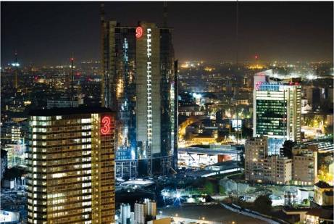
Because of changes in architecture, society and technologies, lighting design faces new challenges. Light shows shape the nocturnal cityscape in urban areas. Zumtobel’s new “Façades and architecture” application area concentrates on special luminaires and lighting control systems for illuminating the façades of buildings. Light is used to set museums, churches, high-rise buildings and shopping malls centre-stage, highlight details or emphasise the size of a building. Zumtobel’s paramount objective is to realise the best possible efficiency as well as prestigious, premium lighting. Striking a balance between these sometimes conflicting priorities demands intelligent lighting solutions complete with modern lighting control systems. Zumtobel’s new lighting repertoire offers the right façade lighting product to suit every requirement.

Aphrodite – a lighting extravaganza with emotive lighting scenes
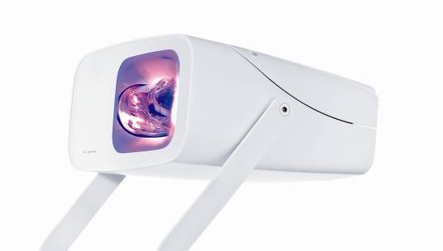
The Aphrodite LED
luminaire developed by Zumtobel in collaboration with designer Nik Schweiger combines light, colour and movement in a fascinating way, providing the basis for animating façades and spaces to great effect. Based on the lighting spectacles found in nature and the biorhythm concept devised by designer Nik Schweiger, the LED spotlight typically provides emotive lighting scenes. In the process, the benefits of LED technology show to particular advantage. Non-repetitive lighting projections are made possible by a specially developed LED module with a motor-driven glass cylinder. A choice of seven pre-defined lighting scenes with three speeds and various dimming levels is available. They create lighting scenarios from functional white light in various colour temperatures, combined with emotive coloured light from red, blue and amber LEDs. The spotlight is operated manually via two momentary-action switches installed directly on the luminaire, or digitally via DMX protocol.

Pylas LED floodlight – targeted illumination without any scattered light
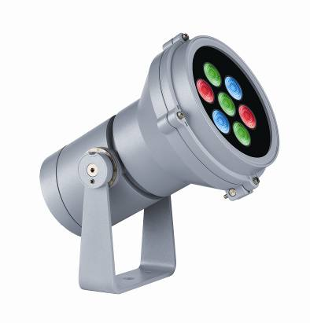
Featuring superior LED technology and efficiency of more than 60 lumens per watt, the Pylas LED floodlight is a pioneer in contemporary façade lighting. Zumtobel’s extensive Pylas product range, which includes four design sizes in an identical design, presents itself as an ideal solution for illuminating façades from various distances and for highlighting details. Pylas is one of the most versatile floodlights available on the market, boasting power ratings from 1.2 to 52.5 W, narrow-beam and wide-beam angles as well as various light colours and RGB models. The luminaire cannot fail to impress with its easy installation and functional design: two layers of powder coating make the IP66-rated floodlight extra durable and robust. Flush-fitting, un-grooved glass panels prevent dirt and water from collecting. The models can be precisely adjusted via a graduated scale and are fixed with a double safety mechanism. The anti-glare accessories available ensure targeted lighting without any scattered light.

Ikono wall-mounted LED luminaire – white lighting cone provides patterns
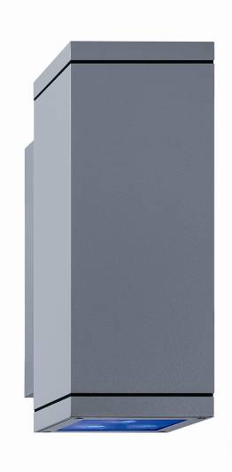
The downlights and down/uplights in the Ikono range of wall-mounted luminaires provide impressive patterns on building façades, creating directional lighting cones in white or variable RGB colours.Ikono is a high-output wall-mounted LED luminaire with IP65 protection featuring focussed light distribution with a wealth of different effects and design patterns. On the outside, the only difference between the downlights and down/uplights available in three design sizes are the dimensions of their square light aperture: 90 mm, 130 mm or 180 mm. Depending on the size and respective lighting task, the most efficient LED technology is selected for each luminaire. This is combined with spot and flood optics matched to the task and a maximum power input of 25 W. The Ikono wall mounted luminaire casts impressive shafts of light in warm or cool white colour temperatures over short or long distances to match the façade material. Installation, too, is customer-friendly: the luminaire housing and the wall fitting made of die-cast aluminium can be connected easily by means of a quick-connect coupler.

Pan recessed LED luminaire – the expert for illuminating windows and cornices
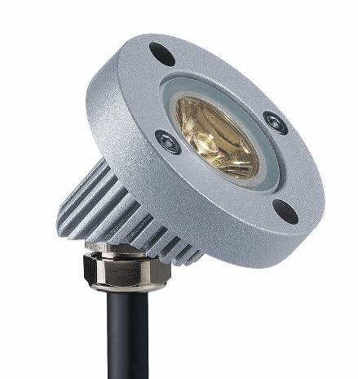
With a diameter of only 52 mm, Pan is the smallest commercially available spotlight for façade lighting. The rugged spotlight can be fitted flexibly in a downlight or uplight position to highlight architectural details, which makes it an expert for illuminating windows and cornices – while remaining perfectly unobtrusive itself. The luminaire, which is made of die-cast aluminium, features IP65/67 protection and comes ready for recessed and for surface mounting using a surface-mounted housing, demonstrates its ability to show off both modern buildings and buildings protected as historic monuments to full effect. Pan is fitted with a high-output LED and requires minimum power of only 1.25 W; it is therefore a contemporary and sustainable alternative to conventional floodlights with high lumen output levels. Thanks to the wide range of models available, the maintenance-free LED luminaire provides plenty of design freedom: the choice of optical systems available includes narrow-beam spots and a wide-angle flood optic through to an elliptical lens with asymmetrical light distribution. Colour temperatures of 3200 K and 6000 K make Pan perfect for illuminating a variety of materials and surfaces such as aluminium and sandstone. Energised with 350 mA, the luminaire can be wired conveniently and quickly using an external supply box with a built-in converter.

Skena wall-mounted special effects luminaire – elegant directional light beams
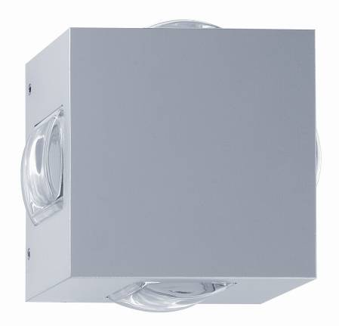
Using the Skena LED luminaire, façades can be set centre stage by extravagant lighting patterns ranging from elegant effects through to geometric compositions, making them shine conspicuously at night. The cube-shaped design of the wall-mounted luminaire with IP66 protection harmoniously blends into the architecture, both inside and outside the building; the luminaire can be installed rotated in increments of 45°. The product range includes three different models with domed lenses or flat panels, emitting the light directed via a conic reflector with distribution characteristics of 2° to 66°. The resulting elegant vertical or horizontal light beams create delicate and large-area effects. With a colour temperature of 6000 K, Skena’s advanced optical system ensures excellent illuminance at low power consumption of only 10 W. It thereby ensures perfect efficiency and a long service life with no need for maintenance.

Luxmate Emotion – the creative tool for dynamic lighting sceneries
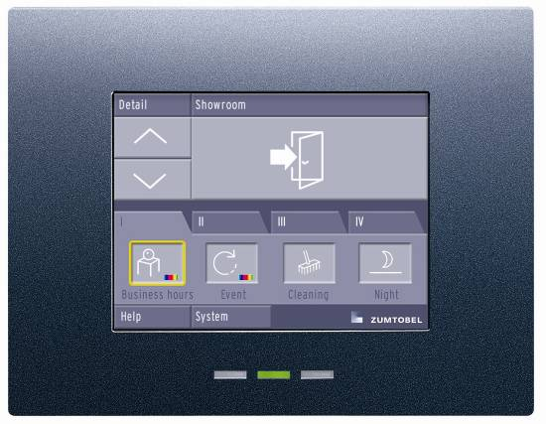
The effectiveness of façade lighting is crucially dependent on the quality of the luminaires used and choosing the right lighting control system. If there is a need to control luminaires on a façade dynamically rather than merely switching them on and off, a lighting management system is required. Zumtobel’s Emotion touch panel is the creative tool that is used to write the screenplay for façade animation. Rhythmic lighting effects as well as gentle, almost imperceptible colour changes are possible, depending on the respective target group and brand message. The Emotion touch panel is the perfect way of coordinating all the available lighting design tools such as spotlights, LED luminaires or coloured luminaires. The floor calendar makes it possible to realise lighting scenarios that are precisely tailored to suit a particular year, week, day and time of day.

Brief profile
The Zumtobel brand is a leading international supplier of integral lighting solutions that enable people to experience the interplay of light and architecture. As a leader in innovation, the luminaire manufacturer provides a comprehensive range of high-quality luminaires and lighting management systems for the most varied application areas of professional interior lighting – including offices and educational facilities, retail and presentation, hotels and wellness, health and care, art and culture as well as industry and engineering. Zumtobel is a brand of the Zumtobel AG group with its head office in Dornbirn, Vorarlberg (Austria).

Captions

Caption 1: Growing by numbers 2011, Milan/IT

Caption 2: Aphrodite – a lighting extravaganza with emotive lighting scenes

Caption 3: Pylas LED floodlight – targeted illumination without any scattered light

Caption 4: Ikono wall-mounted LED range – white lighting cones provide patterns

Caption 5: Pan recessed LED luminaire – the expert for illuminating windows and cornices

Caption 6: Skena wall-mounted special effects LED luminaire – elegant directional light beams

For more information, please contact:
ZumtobelLighting GmbH
Nadja Frank
PR Manager
Schweizer Strasse 30
A-6851 Dornbirn

Tel. +43-5572-390-1303
Fax +43-5572-390-91303
nadja.frank@zumtobel.com
www.zumtobel.com
Publication of this document is free if due acknowledgement is made: Zumtobel

