Press release
Dornbirn, December 2011

Art and architecture – an indivisible unit
Zumtobel creates fascinating façade lighting for urban spaces
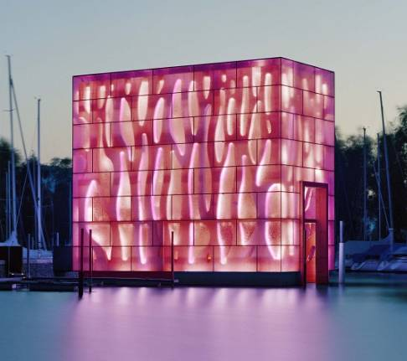
Nowadays, illuminated façades are a feature of every cityscape. Scarcely has daylight faded into twilight, when city centres are transformed into unique places with a distinctive character. Light is used to set museums, churches, high-rise buildings and shopping malls centre-stage, highlight details or emphasise the size of a building. This lends architecture a distinctive expressiveness at night. Zumtobel's new application area concentrates on special luminaires and lighting control systems for façade lighting: from unobtrusively illuminated monuments to resplendent media façades. Stefan von Terzi, Zumtobel's Marketing Director, explains: “The number of buildings that have illuminated façades is increasing sharply. Because of changes in architecture, society and technologies, lighting design faces a new challenge in this area. Our aim is to use our new product portfolio of contemporary façade spotlights to shape urban living spaces in a way that reconciles architecturally inspiring lighting concepts with the highest possible energy efficiency.”

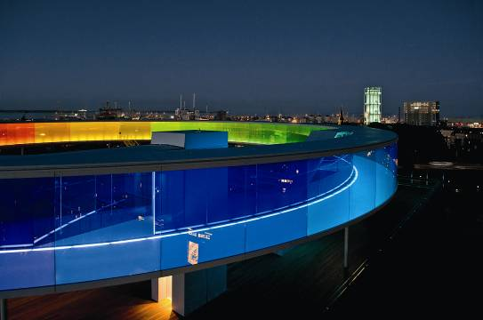
New product portfolio for designing urban living spaces
Façade lighting shapes our nocturnal environment. It helps us find our bearings, conveys moods and emotions and often gives buildings a distinctive image of their own. But it is important not to overlook energy efficiency: nowadays, lighting solutions also need to be sustainable, save resources and prevent unnecessary light pollution. Zumtobel offers a product portfolio of intelligent lighting control systems that are tailored to meet demanding lighting tasks and strike a perfect balance between the differing priorities of centre-stage settings and efficiency: from precisely illuminating the details of a building and uniform façade lighting through to lighting extravaganzas on media façades. The use of modern high-output LEDs cuts energy consumption significantly and reconciles the demands of cultural considerations with the imperative to use resources responsibly.

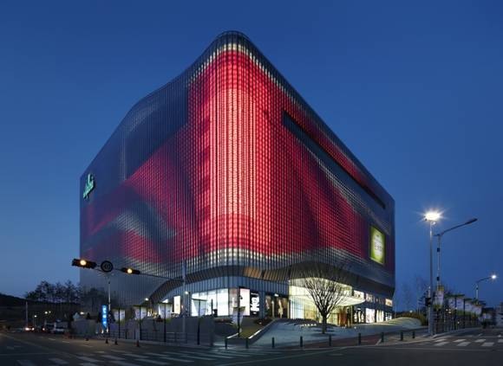
Lively lighting show on the biggest media façade in the world
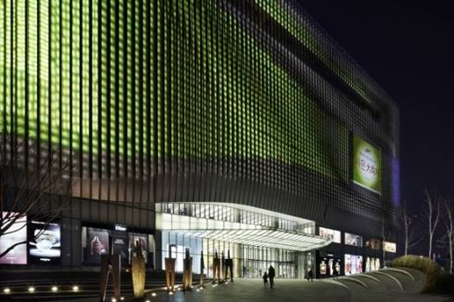
The Galleria Centercity shopping mall in Cheonan, Korea, demonstrates impressively how light can be integrated into a building almost imperceptibly and at the same time be used as a means of communication. The exciting interplay between façade and architecture creates a giant landmark that is visible from afar. This is made possible not just by the huge scale of this “consumer temple” which is breath-taking, but also by the vast 12,600 m² media façade. Dynamic lighting shows produced by more than 22,000 LED lighting points wrap the structure in a shimmering skin. Zumtobel implemented this unique lighting installation jointly with renowned Bonn lighting design firm a.g. Licht and the prestigious Amsterdam architecture firm UNStudio. Zumtobel's IP65-rated RGB LED spotlights and white LED spotlights combine light, colour and movement in a fascinating way. The installed DMX control system ensures individual programming of each LED spot and paints animations on the surface of the building that are accurate in every detail. The LED spotlights are fully integrated into the sections of the outer façade and are therefore invisible to the onlooker. Smoothly flowing lighting sequences, gentle transitions between individual colour sequences as well as messages and images painted with light transform Galleria Centercity into a mystical nocturnal beacon that is truly one of a kind. The shopping mall is a striking example of how façades can become interactive elements of the urban landscape and the way in which urban spaces can be shaped by light – without this indirect, glare-free light causing any nuisance in adjacent areas of the town.

Soft lighting on Chicago’s Rookery Building
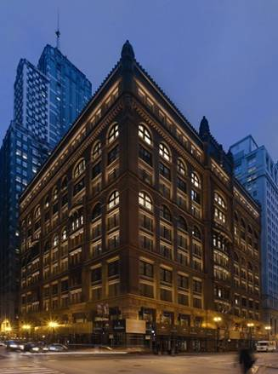
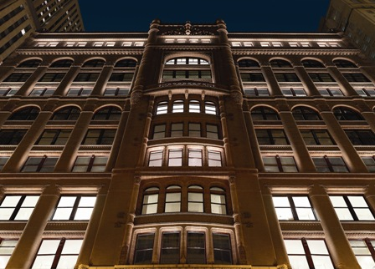
Anyone who stands in front of the Rookery in Chicago feels they have been transported back to another age. The first modern building with a steel frame in its day, it is faced with blocks of red granite and, thanks to its ambitious architectural aspirations, stands out majestically from the high-rise buildings that surround it. The Rookery can look back over a long history: built in 1888 by architects Daniel Burnham and John Root, the 11-story structure was the tallest building in the world at that time. Nowadays it is considered a forerunner of our modern skyscrapers. Because it is architecturally unique, the office building has been listed in the National Register of Historic Places since 1970. It is not just its interior, designed by Frank Lloyd Wright, that hides unique, fascinating architectural features. The façade of the high-rise which is decorated with ornate stucco is another aspect of this architectural jewel. At night, the building shines out like a vision from a One Thousand and One Nights' fairytale. This is all made possible by the innovative OVI lighting concept that was implemented by Zumtobel. A specially manufactured custom LED luminaire was developed in order to achieve soft, but nevertheless precise, lighting. The luminaire has a special oval optic which highlights the fine stucco work to perfection. In the event of excessively high temperatures, the luminaire is capable of automatically dimming down to the correct thermal limits and also incorporates the requisite IP65 protection. The special luminaires are mounted on holders attached to the window frames in order to minimise light pollution which might otherwise damage the fragile natural stone. The light sources cannot be seen from the road below. In the evening, the Rookery is a breathtaking symbol of timelessness and is becoming a new highlight of Chicago's financial district.

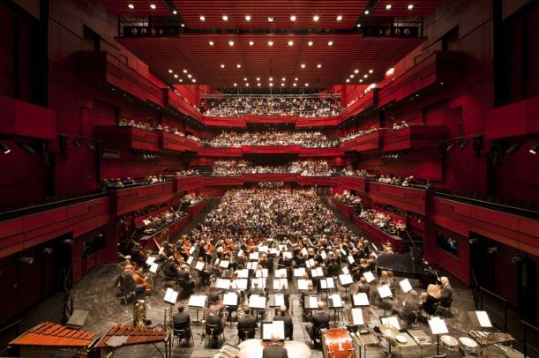
Artificial lighting as lighting art in the “Harpa” Concert Hall in Reykjavik
The new 28,000 m² “Harpa” Concert Hall and Conference Centre built in 2011 on Reykjavik's lively waterfront gleams with all the sparkle of polished crystal. This impression is heightened by the honeycomb structure of the façade, especially by the individual façade sections made of dichroitic glass panes. These reflect daylight and make the façade sparkle in hues of green, yellow, orange or their complementary colours. Thanks to these reflections and permanent changes in colour tone and colour intensity, the building seems to capture light in a magical way. Art and architecture merge into a single indivisible unit.

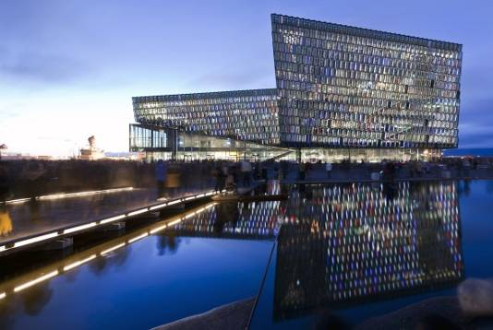
This effect is particularly impressive in the evening when the south façade begins to glow mysteriously. This spectacle is produced by LEDs strip lights that are installed on the inside of the structure and remain invisible during the day. For this purpose, the architect Olafur Elíasson developed, in collaboration with Zumtobel, a completely new type of luminaire which, thanks to its design and colour, can be integrated nearly invisibly into the prismatic structure. This creates the impression that the façade, rather than simply being illuminated, is suffused with an internal glow. The roughly 1.37 m long special luminaires, each with a total output of 13.2 W, use a special housing where the light emitted by the LEDs first has to pass through a “light mixing chamber” before it penetrates a light scattering plastic section consisting of several components. In order to conceal both the attachment points and cables, the LEDs are connected to the mains supply and data network via invisibly laid cables, partly within the bearing structure, partly in the sealing joints of the glass modules. In terms of colour and lighting intensity, the LED lines are individually controlled and dimmable down to 1% of the maximum light output, enabling lighting scenarios ranging from spherical colour sequences to the presentation of animated pictures. Every evening, “Harpa's” external appearance is transformed into a building that is just as emotive and charged with energy as Iceland itself.

Zumtobel. The Light
Fact box: Nordwesthaus Rohner, Fussach/AT
Architects: Baumschlager Eberle, Lochau/AT
Lighting solution: 12 RGB LED spotlights with 1,500 individually controllable LEDs and an asymmetric optic, controlled via DMX 512, 100 W QT recessed downlights (custom solution)

Fact box: Your rainbow panorama, Aarhus/DK
Architects: Studio Olafur Eliasson, Berlin/D
Lighting solution: Special solution: 116 indirect luminaires with special reflector technology (1/54 W)

Fact box: Galleria Centercity, Cheonan/KR
Architecst: UNStudio, Amsterdam/NL
Lighting solution: RGB LED spotlights with IP65 protection and white LED spotlights (custom solution)

Fact box: The Rookery Building, Chicago/US
Architects: Burnham & Root, Chicago/US
Lighting solution: ROOK LED surface-mounted spotlights(custom solution)

Fact box: HARPA Reykjavik Concert Hall, Reykjavik/IS
Architects: Henning Larsen Architects, Copenhagen/DK
Lighting solution: LED light lines for illuminating the façade (custom solution); interior lighting using the TECTON Tetris continuous-row lighting system and PANOS downlights

Brief profile
The Zumtobel brand is a leading international supplier of integral lighting solutions that enable people to experience the interplay of light and architecture. As a leader in innovation, the luminaire manufacturer provides a comprehensive range of high-quality luminaires and lighting management systems for the most varied application areas of professional interior lighting – including offices and educational facilities, retail and presentation, hotels and wellness, health and care, art and culture as well as industry and engineering. Zumtobel is a brand of the Zumtobel AG group with its head office in Dornbirn, Vorarlberg (Austria).

Captions:

Caption 1: Illuminated Nordwesthaus on Lake Constance

Caption 2: Your rainbow panorama – made of coloured glass walls

Caption 3: Galleria Centercity shopping mall in Cheonan, Korea

Caption 4: Galleria Centercity's media façade

Caption 5 + 6: The Rookery Building in Chicago

Caption 7: The auditorium of the Harpa Concert Hall

Caption 8: Harpa Concert Hall in Reykjavik by night

For more information, please contact:
ZumtobelLighting GmbH
Nadja Frank
PR Manager
Schweizer Strasse 30
A-6851 Dornbirn

Tel. +43-5572-390-1303
Fax +43-5572-390-91303
nadja.frank@zumtobel.com
www.zumtobel.com

Publication of this document is free if due acknowledgement is made: Zumtobel; 3+4 Kim Yong-kwan

