Press release
Dornbirn, November 2011

Art presented in the right light
Zumtobel develops intelligent lighting systems for museums and art galleries

In our world, light is of vital importance. Light has an influence on atmosphere and changes rooms. In museum areas, light is an essential factor. It creates worlds of experience, and highlights and enhances the presentation of exhibits with public appeal. For more than 50 years, Zumtobel has collaborated with renowned architects and lighting designers in the area of art & culture to develop innovative, high-quality lighting solutions that can be individually adjusted to fit any exhibition building.

Museums are frequently faced with major challenges, as they usually have to deal with extremely valuable and delicate exhibits. Depending on the respective exhibition concept, varying lighting solutions are required that are intended to subtly illuminate the exhibits and sculptures on display, providing for maximum enjoyment of art. Museums putting sculptures or paintings on show need lighting that is different from that for interactive exhibitions. Here, light's task is to give each exhibit its own, distinctive identity, setting them all centre stage. Proper thermal conditions, the authentic rendering of colours, and taking the sensitivity of ancient scripts, sculptures or paintings into account are perennial challenges to be mastered by designers and lighting designers.

Energy efficiency
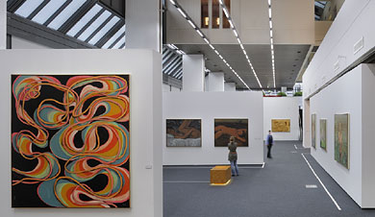
For light-sensitive exhibits in particular, concepts are needed that provide for controlled use of daylight and artificial lighting. Intelligent lighting control systems make it possible to precisely determine the amount and intensity of daylight and artificial light. This is not only good for the exhibits, but also helps to save energy - an important issue for museums, as is shown in an exemplary manner by the refurbished Wilhelm-Hack-Museum in Ludwigshafen. Thanks to an efficient lighting management system, the museum's energy costs have been slashed by as much as 70%. The lighting can be controlled as required. Each luminaire can be dimmed individually. This lighting system allows for perfect illumination of the exhibits on display while ensuring protection of the valuable items against excessive heat and UV radiation.

Solutions meeting special requirements
However, energy efficiency is not the only issue important to exhibition buildings. Each museum has a different concept, has different lighting requirements. Museums presenting permanent exhibitions have other needs than buildings with temporary exhibitions. Based on its many years of application know-how, Zumtobel - jointly with international architects and lighting designers - develops innovative lighting systems that allow to adjust brightness and colour temperatures to the special requirements of any exhibition at all times. A good example is Zumtobel's collaboration with the renowned David Chipperfield architects studio, for instance; where a spotlight range has been developed that focuses on what is essential, therefore ensuring perfect illumination of museums, art galleries and exhibition areas. Owing to their special properties, these LED spotlights make sure that paintings are not damaged or faded by harmful UV or IR radiation. Annoying reflections are prevented by an anti-glare panel integrated in the spotlight design. "I have always been interested in reducing architecture to a very simple, basic idiom and in emphasising space, the materials used, and light", comments David Chipperfield on his ideas about light and art. This is shown very impressively in the Museo del Tessuto in Italy. For reasons of conservation, the valuable medieval exhibits of textile art and textile technology must not be exposed to daylight. In the exhibitions areas, ambient lighting has therefore been reduced to a minimum. Here, the lighting system by Zumtobel allows to create gentle accents, producing a unique, emotional atmosphere.

Turning visions into reality
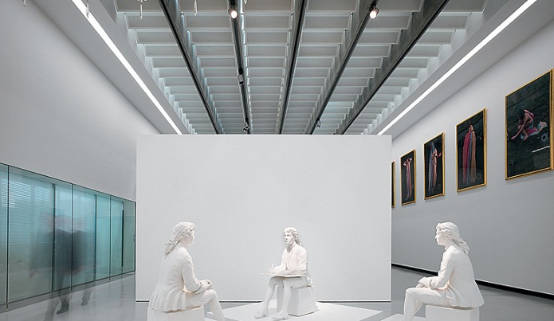
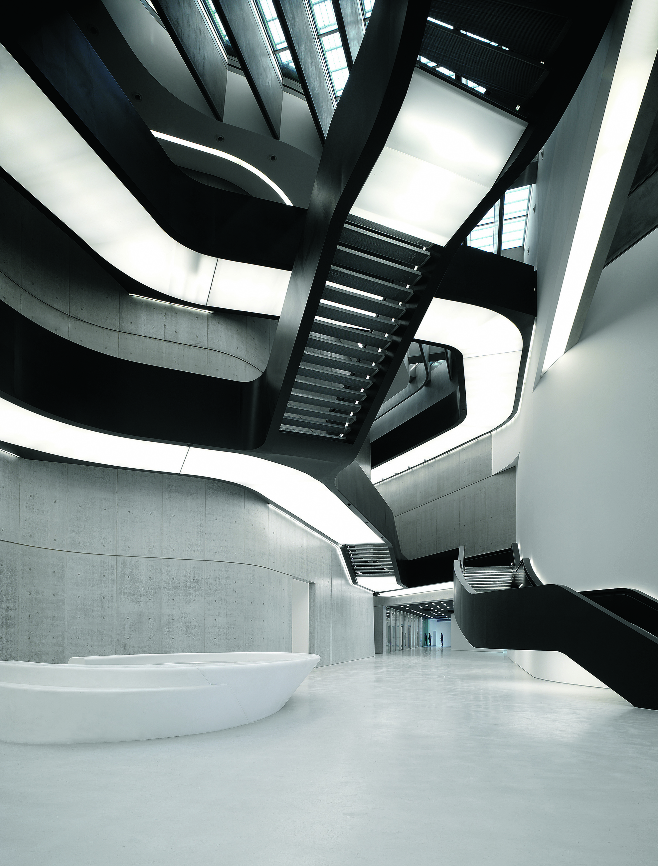
Zumtobel also helps others to turn visionary ideas into reality. For instance, innovative lighting compositions have turned the BMW Museum in Munich into a fictive city that seems to be built of light. Each building is characterised by an individual identity with a specific appearance and appropriate lighting design. Thus, walking through the automobile museum with its very special atmosphere turns into an impressive experience.

Visitors of the MAXXI Museum in Rome are also bestowed with a fascinating lighting experience. In the MAXXI, the Museonazionaledellearti del XXI secolo, ZahaHadid Architects have implemented the idea of flowing shapes and drifting into a powerful continuum of space. In this building, daylight and artificial lighting are used to enhance the dynamic architecture. The cantilevered building units form projecting roofs guiding visitors into the foyer, a lobby as high as the building, traversed by staircases and crosspieces - a Piranesi-style space made of light concrete and black steel. The dynamic staircase sculpture does not only interlink the five exhibition levels, but also sets the stage for the flow of movement across the "vertical piazza". Natural light travels from the glass roof down to the floor, accurately adjusted by a specially developed luminous ceiling, which also incorporates indirect lighting by fluorescent lamps that can be switched on if required. This combined system provides uniform ambient lighting. In addition, the architects have used artificial lighting deliberately as a means of creative design: "In the lobby, we have set a lighting stage. All luminaires have been integrated into the architectural elements, forming linear structures highlighting the pathways" - this is how GianlucaRacana, the project architect, explains the concept.

In art and culture, therefore, the lighting concept, the luminaire and the lighting management system play the leading part to ensure maximum efficiency and lighting quality. Thanks to its lighting solutions, Zumtobel not only supports the world of culture of today, but also develops lighting visions to take on the challenges of tomorrow.

Zumtobel. The Light.

Brief profile
The Zumtobel brand is a leading international supplier of integral lighting solutions that enable people to experience the interplay of light and architecture. As a leader in innovation, the luminaire manufacturer provides a comprehensive range of high-quality luminaires and lighting management systems for the most varied application areas of professional interior lighting – including offices and educational facilities, retail and presentation, hotels and wellness, health and care, art and culture as well as industry and engineering. Zumtobel is a brand of the Zumtobel AG group with its head office in Dornbirn, Vorarlberg (Austria).

Captions:
Caption 1: Energy-efficient lighting solution at the Wilhelm-Hack-Museum in Ludwigshafen

Caption 2: Conservational lighting by Zumtobel at the Museo del Tessuto/Italy

Caption 3: MAXXI Museum in Rome with a lighting concept by Zumtobel

Caption 4: MAXXI Museum in Rome: dynamic staircase sculpture

Publication of this document is free if due acknowledgement is made: Zumtobel

For more information, please contact:
Zumtobel Lighting GmbH
Nadja Frank
PR Manager
Schweizer Strasse 30
A-6851 Dornbirn
Tel. +43-5572-390-1303
Fax +43-5572-390-91303
E-mail: nadja.frank@zumtobel.com
www.zumtobel.com

