Press release

Four to score
Zumtobel quartet wins iF product design award 2013

Dornbirn, January 2013 - Zumtobel was able to demonstrate its design expertise at the iF International Forum Design. As many as four products by the Austrian luminaire manufacturer received the 2013 iF product design award for their outstanding product design and efficient lighting technology. The Discus Evolution spotlight system, the Elevo LED spotlight, the Pan recessed LED luminaire and the Onlite Puresign 150 escape sign luminaire could not fail to impress the jury with their design and innovative power.

Discus Evolution – LED spotlight system
The Discus Evolution LED spotlight system results from further development of an existing luminaire and cannot fail to impress on account of its perfectly matched light source and optic. The spotlight's flat design is now even more contemporary and minimalist. The delicate yet robust design of the spotlight created by the internationally renowned Vienna-based EOOS design studio was created for accent lighting and sales-boosting presentation of goods. The spotlight's innovative thermal management using a passive cooling system with radial fins is an integral part of the design concept. Discus Evolution is available with an unobtrusive black or white housing and suitable both for installation on tracks and for recessed installation.

Elevo – LED spotlight
With just 3.5 cm, the flat Elevo LED spotlight is reduced to minimum height. It emphasises façade features, relief slabs and projecting features, backlights surfaces uniformly and sets tall columns and portals centre stage with equally striking effectiveness. The flat, compact design of the Elevo LED spotlight turns it into an inconspicuous integral part of the façade that is invisible to passers-by yet highly effective. Elevo's design was created by the internal product development team of Zumtobel Lighting GmbH.

Pan – recessed LED luminaire
Product development of the Pan recessed LED luminaire focused on accentuating windows, parapets and alcoves. Thanks to its extremely compact design, the Pan recessed luminaire can be completely integrated into the façade structure. An anti-glare device especially developed for this luminaire eliminates any trace of undesired glare. Precise light distribution sets Pan clearly apart from bulky floodlights that illuminate large areas of façades and look out of place in the daytime. The Pan recessed LED luminaire was created by the internal product development team of Zumtobel Lighting GmbH.

Onlite Puresign 150 – emergency lighting
Zumtobel is also collaborating with the renowned EOOS design studio to develop escape sign luminaires boasting clear functionality and elegant shapes. At a width of just 20 mm, the Puresign 150 luminaire is strikingly slim, even in the duplex version. Thanks to cutting-edge LED and lighting technology, the pictograph is illuminated highly effectively and uniformly. Rotatable ERI spots on the underside ensure that the emergency luminaires can be specifically adjusted to the building's requirements. For the new generation of Puresign, four new installation options have been added to the existing product portfolio: recess into walls and ceilings, surface mounting using cords, and a remote box version.

iF design
The iF awards rank among the most important design labels worldwide. Winners are chosen by independent juries comprising internationally renowned designers, businessmen and professors according to specific pre-defined criteria. Each year, the best designs of innovative companies are given awards in various categories. The iF award is considered an indicator of future-oriented design trends and product innovations. Entries for the famous design award included a total of 3,011 products submitted by more than 1,920 competitors. 981 of these products have won an award. 75 of all award winners from these three competitions will be given the iF gold award for special design performance during the prize awarding ceremony to be held at the BMW World in Munich on 22 February 2013.

Captions:

(Photo credits: Zumtobel)

Caption 1: The DISCUS Evolution LED spotlight system cannot fail to impress on account of its minimalist design and high efficiency.
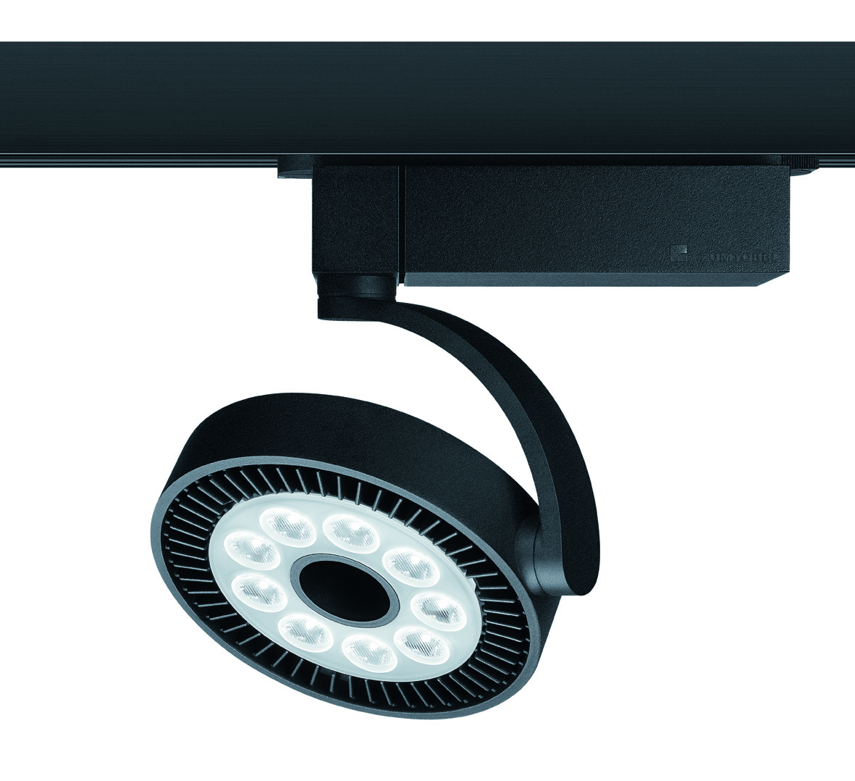

Caption 2: The compact Elevo LED spotlight is ideal for highlighting façade features and surfaces.
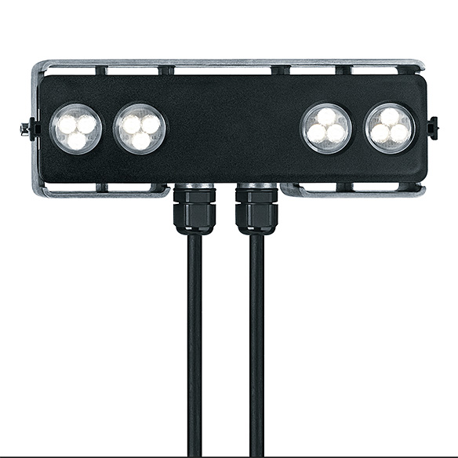

Caption 3: The Pan recessed LED luminaire can be integrated into the façade structure and provides precise accent lighting for windows, parapets and alcoves.
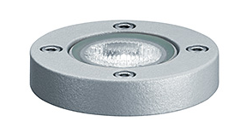

Caption 4: The Onlite Puresign 150 emergency luminaire boasts clear functionality and an elegant design.


For more information, please contact:
Zumtobel Lighting GmbH
Nikolaus Johannson
Head of Brand Communication
Schweizer Strasse 30
A-6851 Dornbirn

Tel. +43-5572-390-26427
Mobile +43 664 80892 3202
E-mail nikolaus.johannson@zumtobel.com

www.zumtobel.com

About Zumtobel
Zumtobel is a leading international supplier of integral lighting solutions that enable people to experience the interplay of light and architecture. As a leader in innovation, the luminaire manufacturer provides a comprehensive range of high-quality luminaires and lighting management systems for the most varied application areas of professional interior lighting – including offices and educational facilities, presentation and retail, hotels and wellness, health and care, art and culture as well as industry and engineering. Zumtobel is a brand of Zumtobel AG with its head office in Dornbirn, Vorarlberg (Austria).

Zumtobel. The Light.

