Press release

PANOS infinity – Not just a luminaire family for architectural lighting
The PANOS infinity luminaire family has established itself as a sophisticated “building block” for every lighting task. Now four new variants further strengthen the reputation of this downlight as a perfectly tailored lighting solution. Specific versions with carefully engineered light distributions stimulate the creativity of every planner.
Dornbirn, November 2016 – The PANOS infinity luminaire family from Zumtobel is the epitome of formally integrated architectural lighting. The four new variants presented for the first time in November 2016 help increase the potential for lighting solutions that correspond to the finer details of every application. The light distribution of each PANOS version is specially optimised to reflect the different requirements in a building – including functional illumination. PANOS infinity therefore effortlessly meets the varied demands placed on general and accent lighting, such as ensuring homogeneous illumination of horizontal and vertical surfaces with high light quality, enabling precise accentuation and creating a pleasant atmosphere. As a result, Zumtobel has crafted a product portfolio with high aesthetic appeal that covers every lighting task and inspires every lighting planner.
A choice of round and square designs, frameless or with a mounting frame, with diameters of 68 mm, 100 mm and now also with a diameter or edge length of 200 mm, helps fuel this inspiration. The PANOS infinity “building blocks” empower architects, lighting designers and electric planners to devise optimal task-specific lighting solutions for every room – solutions that are optimal both in terms of the overall building concept and the wellbeing of individual users. Whether in a reception area or a corridor, an office or a conference room, a lobby or an informal communication zone, a shop or a museum, one thing remains constant: both the discrete-looking downlights and the fine wallwashers blend beautifully with the interior architecture, combining norm-compliant illumination with high system efficiency and a specific lighting effect.
Precise light control with added know-how
These benefits are the direct result of high-quality lens and reflector technologies, which stem from Zumtobel’s proven competence and vast experience in all elements of lighting design. Lens systems are characterised by exact light control, less stray light and the ability to produce various beam angles, including narrow distributions. The reflector then functions as a design element. Brightness is reduced, glare is limited and visual comfort is enhanced. The “pure” reflector technology retains an important role in downlights with large diameters and high luminous fluxes, helping to negate the need for complex solutions with several lens systems. As a result, a diverse range with a single uniform look delivers precisely the right light control for every lighting task.
The new additions introduce the possibility of “warm dimming” and an excellent colour rendering index of CRI> 90, along with colour temperatures of 2700 K, 3000 K and 4000 K, as well as 3500 K for the American market. The comprehensive PANOS infinity portfolio helps further increase its immense application potential.
New versions with task-specific charm
The PANOS infinity High Lumen downlight, with a diameter of 200 mm and an extremely high luminous flux of up to 7400 lumens, is ideal for use in high rooms such as atriums, airport buildings and hotel lobbies. The light distributions are defined by the reflector geometry, helping engineer two versions with specific beam angles: Spot with 13° and Flood with 30°. These high-performance “large-scale” recessed luminaires represent useful new tools for the creation of attractive architectural lighting with a uniform aesthetic character.
The PANOS infinity Accent Beam downlights put the emphasis firmly on accent lighting. The round design has a diameter of 100 mm and the square version has an edge length of 100 mm. Driven by a dedication to ensure perfect presentation with outstanding lighting quality, high-quality lens technology has been harnessed to define three distinct beam angles: Spot with 14°, Flood with 29° and Very Wide Flood with over 50°. The model with a black reflector is a particular design highlight. This feature may have little effect in terms of lighting technology, but it means that users see a calm, uniform ceiling rather than merely “light from above”, thereby enhancing visual comfort.
Focused accents are also provided by the “small” PANOS infinity adjustable, which is only 68 mm in either diameter or edge length, depending on whether the round or square version is selected. Using a specially developed lens system, the light cone can be swivelled by up to 28° and rotated 355°, guaranteeing optimal alignment without the need for any tools. The range includes Spot with a 15° beam angle and Flood with a 30° beam angle.
The miniaturised PANOS infinity wallwasher is optimised for the homogeneous illumination of vertical surfaces with up to 825 lumens of high-quality light. Boasting a diameter or edge length of just 68 mm, with a mounting frame or simply frameless, these luminaires nicely complement the “bigger” members of the PANOS infinity family.
Every architect or planner can now use the carefully thought-out PANOS infinity range from Zumtobel to truly indulge their creative instincts. The downlight, wallwasher and directional downlight “building blocks”, crafted in line with the design vision of Chris Redfern, Sottsass Associati, reflect every facet of lighting competence. Together with a consistent look, the PANOS infinity modular system offers unprecedented design freedom. The result is a raft of fascinating lighting solutions, ranging from functional lighting tasks focused on system efficiency to high-quality architectural lighting.
PANOS infinity adjustable 100mm video available:
https://youtu.be/1uUPyooa0L4

Photo captions:
(Photo credits: Zumtobel)
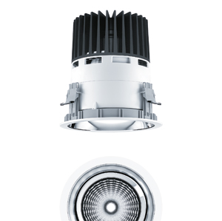
Photo 1: The PANOS infinity High Lumen downlight with a diameter of 200 mm is ideal for use in high rooms such as atriums, airport buildings and hotel lobbies.
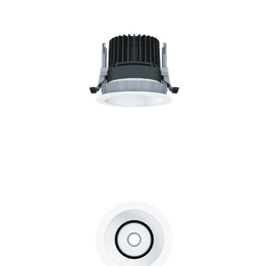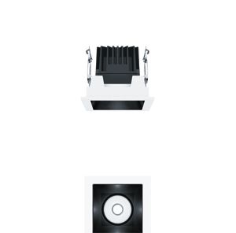
Photo 2: The Accent Beam versions of the PANOS infinity range put the emphasis firmly on accent lighting.
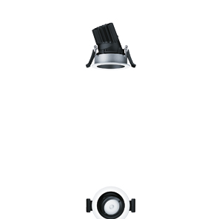
Photo 3: Focused accents are also delivered by the “small” PANOS infinity adjustable, which is only 68 mm in either diameter or edge length.
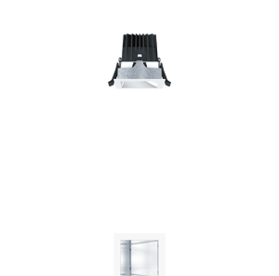
Photo 4: The miniaturised PANOS infinity wallwasher is optimised for the homogeneous illumination of vertical surfaces.

Press contact:
Zumtobel Lighting GmbH  Kiki McGowan  Head of Brand Communications  Schweizer Strasse 30  6850 Dornbirn  Phone: +43 5572 309 1303  kiki.mcgowan@zumtobelgroup.com  www.zumtobel.com | Zumtobel Lighting GmbH  Andreas Reimann  Brand PR Manager  Schweizer Strasse 30  6850 Dornbirn  Phone: +43 5572 390 26522  andreas.reimann@zumtobelgroup.com  www.zumtobel.com
Zumtobel Group  Jennifer Sewell  Marketing Communications Manager  Chiltern Park, Chiltern Hill  Chalfont St Peter, Buckinghamshire SL9 9FG  United Kingdom  Phone: +44 0 7785 232 294  jennifer.sewell@zumtobelgroup.com  www.zumtobel.com | Zumtobel Lighting Inc.  Karianna Haasch  Marketing Manager Americas  Zumtobel Lighting US  3300 Route 9W  Highland, NY 12528-2630  Phone: +1 845-691-6262 - 7611  karianna.haasch@zumtobelgroup.com  www.zumtobel.us

About Zumtobel
As a leader in innovation, Zumtobel develops sustainable lighting solutions tailored to the needs of people in their respective applications. With a comprehensive portfolio of high-quality luminaires and intelligent lighting management systems, the Austrian company provides optimum indoor and exterior products for working and living spaces - the right light for every activity at any time of day. The applications office, education, presentation and retail, hotel and wellness, health, art and culture and industry are now perfectly complemented with portfolios for living and outdoor areas. Zumtobel is a brand of Zumtobel Group AG with its head office in Dornbirn, Vorarlberg (Austria).
Zumtobel. The Light.

