Press release

The new MELLOW LIGHT
An icon returns to set new standards in office lighting
The new MELLOW LIGHT is far more than just an innovative LED luminaire. The sixth generation of this office lighting icon sets new standards when it comes to adapting lighting to suit the specific needs of users, drawing on extensive Zumtobel knowledge about how light affects humans on a visual, biological and emotional level.
Dornbirn, November 2016 – MELLOW LIGHT is also characterised by an exciting new design. Daniel Stromborg, Practice Area Leader at Gensler, has succeeded in developing the style of the luminaire while still retaining a clear link to 25 years of lighting history. Immediately recognisable yet slimmer and more elegant, the form supports the state-of-the-art lighting technology that helps this design icon adapt perfectly to the constantly changing requirements of the contemporary office.
MELLOW LIGHT evolution and infinity
Both the look and the vision of MELLOW LIGHT are unmistakable, with these two aspects combining to deliver high quality light that is as close as possible to natural daylight. To achieve this difficult feat, MELLOW LIGHT has been extensively developed and is now available in two versions: MELLOW LIGHT evolution and MELLOW LIGHT infinity. Both variants ensure the balanced illumination of work surfaces, walls and ceilings to create an open, bright room atmosphere in which glare and disturbing shadows become a thing of the past.
Both versions are also available with the tunableWhite technology by Zumtobel, allowing the light intensity and colour temperature to be independently and seamlessly adjusted between 3000 and 6000 K. MELLOW LIGHT evolution and MELLOW LIGHT infinity can therefore be used for the implementation of the "Active Light" concept developed by Zumtobel, which imitates the dynamics of daylight that are so important for humans. In the spirit of Human Centric Lighting, tunableWhite supports the natural biorhythm and offers maximum visual comfort for different tasks by providing the right light at the right time, with the appropriate intensity and colour. On an emotional level, this also has a positive influence on communication and the creativity of employees.
MELLOW LIGHT infinity goes one step further, as the outer wings and the central segment can now be controlled independently of each other. In line with the results of a Zumtobel user study into perceived light quality in the office, which revealed that many people find the standard 500 lux insufficient, MELLOW LIGHT infinity enables the individual and flexible adaptation of the light to reflect different needs, preferences and situations. The two light wings create a pleasant basic brightness of 300-400 lux, which gives the room a welcoming atmosphere, while work surfaces can be perfectly illuminated with an additional 400 lux from the central segment.
Combining MELLOW LIGHT infinity with the LITECOM lighting management system and the innovative ATIVO contrast sensor means that the light atmosphere can be automatically adjusted to reflect not only the amount of available daylight, but also the number of people present and their location in the room. ATIVO recognises the way a space is being used and automatically selects the appropriate lighting mood, paving the way for Activity Based Lighting.
Different optics for maximum light
While the outer wings provide the soft and diffuse light synonymous with MELLOW LIGHT, there is a choice of two optics for the central section. The crystal optic is a new interpretation of the classic lens optic, guaranteeing glare-free illumination with up to 4800 lumens. This makes the crystal optic ideal for applications where more than 500 lux is required or where there are larger distances between the luminaires. The lenticular optic uses prism louvres to blend a gentle and homogeneous appearance with excellent glare suppression for up to 3500 lumens. Both optics meet the relevant standards for VDU workstations with UGR < 19.
The central segment and the diffuse outer wings are separated by a delicate chrome accent, which has a very special significance for the designer Daniel Stromborg: "It was a great honour for me to further develop James Irvine’s design of the last MELLOW LIGHT, as I have great respect for his work. Irvine inserted a small step between the wing and the actual light source, which we most definitely wanted to retain as a homage to James and his team. A very subtle detail arises from the interaction between the crystalline primary optic and this step, which I also call the 'Irvine Step'. This effect plays an important role in our overall design concept."
Design variety
The MELLOW LIGHT portfolio encompasses a comprehensive range of rectangular and square luminaires in a wide variety of designs for ceiling-recessed or surface-mounted installation. The recessed luminaire is available for the M600 and M625 module sizes. As a surface-mounted fitting, a series of optional colours helps the luminaire adapt to the individual needs of the interior architecture. While the white luminaire can be discreetly integrated into drywall ceilings, the silver version creates a flexible transition between the product and the exposed concrete. If highlights are required, additional versions in brown, black and naturally anodised aluminium can be specified. The optional colours can be easily viewed and ordered from the myMELLOW LIGHT section of the online product catalogue.
Global roll-out
MELLOW LIGHT is the first Zumtobel luminaire to be launched directly with an international platform. This helps guarantee a uniform lighting concept for all users, no matter if they are in Dubai or in China.

Captions:
(Photo Credits: Zumtobel)
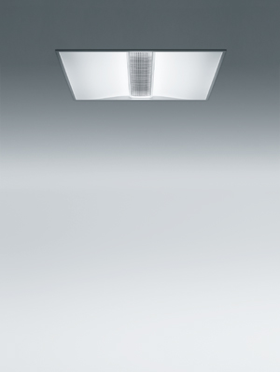
Fig. 1: Both the look and the performance of MELLOW LIGHT are unmistakable, with these two aspects combining to deliver high quality light that is as close as possible to natural daylight.

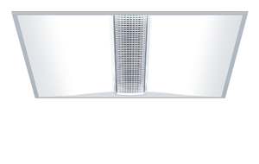
Fig. 2: The MELLOW LIGHT portfolio encompasses a comprehensive range of rectangular and square luminaires in a wide variety of designs for ceiling-recessed or surface-mounted installation.

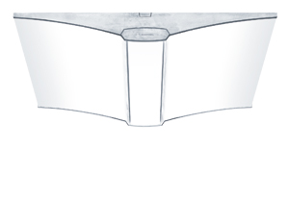
Fig. 3: As a surface-mounted fitting, a series of optional colours helps the luminaire adapt to the individual needs of the interior architecture.
Press contact:
Zumtobel Lighting GmbH  Kiki McGowan  Head of Brand Communications  Schweizer Strasse 30  6850 Dornbirn  Phone: +43 5572 390 1303  kiki.mcgowan@zumtobelgroup.com  www.zumtobel.com | Zumtobel Lighting GmbH  Andreas Reimann  Brand PR Manager  Schweizer Strasse 30  6850 Dornbirn  Phone: +43 5572 390 26522  andreas.reimann@zumtobelgroup.com  www.zumtobel.com
Zumtobel Group  Jennifer Sewell  Marketing Communications Manager  Chiltern Park, Chiltern Hill  Chalfont St Peter, Buckinghamshire SL9 9FG  United Kingdom  Phone: +44 0 7785 232 294  jennifer.sewell@zumtobelgroup.com  www.zumtobel.com | Zumtobel Lighting Inc.  Karianna Haasch  Marketing Manager Americas  Zumtobel Lighting US  3300 Route 9W  Highland, NY 12528-2630  Phone: +1 845-691-6262 - 7611  karianna.haasch@zumtobelgroup.com  www.zumtobel.us

About Zumtobel
As a leader in innovation, Zumtobel develops sustainable lighting solutions tailored to the needs of people in their respective applications. With a comprehensive portfolio of high-quality luminaires and intelligent lighting management systems, the Austrian company provides optimum indoor and exterior products for working and living spaces - the right light for every activity at any time of day. The applications office, education, presentation and retail, hotel and wellness, health, art and culture and industry are now perfectly complemented with portfolios for living and outdoor areas. Zumtobel is a brand of Zumtobel Group AG with its head office in Dornbirn, Vorarlberg (Austria).
Zumtobel. The Light.

