Press information

Zumtobel builds a bridge to nature with Active Light
Dynamic lighting solutions for active lifestyles
Connecting with nature - Active Light supports human nature by drawing inspiration from the character and dynamics of natural light. It takes the three levels of light into account (visual, emotional and biological) and adapts four specific light dimensions to suit constantly changing human needs by modifying intensity, direction, colour and time. This essential relationship between humans and light supports people naturally in every aspect of their personal and professional lives.
Dornbirn, November 2016 – Light is our invisible companion. It helps us perceive the world with our eyes and creates an appropriate atmosphere without us even realising – during the day and at night. It is responsible for the synchronisation of our sleep-wake rhythm and influences essential bio-chemical processes that take place in the body. The light of the sun shapes reality in a variety of ways and represents the original natural light source with which individuals are connected, forming a key elementary relationship. Yet the majority of people in industrialised countries now spend around 80 per cent of the day indoors, often without the beneficial effects of direct daylight. As a result, the connection to the natural timer of the internal clock is increasingly being compromised.
Connecting with nature - Natural light is dynamic
Compared to mostly static artificial light solutions, the light of the sun encompasses a variety of different facets. Active Light is based on this rich diversity, distinguishing between light intensity and colour as well as light direction and timing. These four dimensions of light are adapted dynamically to suit the needs of the human being, helping each individual experience positive light effects on a visual, emotional and biological level. In addition, Active Light integrates the knowledge gained from studies and research, along with extensive practical experience in various different application areas. By adopting a holistic approach, Active Light responds to the special relationship between people and light and provides the right light at the right time – right through the day and the night.
Dynamic light works
Active Light delivers sustainable added value in every application by putting the focus firmly on specific requirements. Shaped by the individual needs, tasks and preferences, Active Light is defined by a dynamic that helps stabilise the natural biorhythm of the human being, enabling maximum visual comfort and stimulating positive emotions.
Creating light creates inspiration - The right light not only optimises visual comfort in the office. Active Light brings the dynamics of daylight to the workplace, supporting the natural biorhythm and enhancing wellbeing and satisfaction, while also helping foster a positive atmosphere in terms of communication and creativity. For example, the new MELLOW LIGHT could be included in this type of lighting solution. With the help of tunableWhite technology and intelligent control systems such as LITECOM, this luminaire adapts its colour temperature and light intensity throughout the course of the day. In addition, MELLOW LIGHT provides more light than stipulated in the latest lighting standards, offering users the chance to work with up to 800 lux, depending on individual preference and the current task.
Creating light creates precision - Active Light in industrial applications takes into account the visual, emotional and biological needs of both those who are busy during the day and those who work through the night. Activity-based lighting is also possible when lighting control systems are supplemented with innovative sensors such as the ATIVO contrast sensor. New sensor technology not only transmits information about light readings and presence, but can even recognise the number and location of people in a space, along with the frequency and patterns of their movements. This capability helps make sure that the right lighting scenario is provided for a particular activity and additionally supports safety, precision and quality.
Creating light creates emotion – Blending Active Light with Zumtobel's Limbic® lighting approach in retail applications makes it possible to impeccably showcase brands and products for specific target groups. It creates emotional experiences that appeal to all the senses of the consumer. Highly efficient downlights like PANOS infinity harness tunableWhite technology to provide an excellent colour rendering of Ra 90 across a broad range of colour temperatures. This guarantees maximum design flexibility, as the light can be carefully tailored to complement the colour and material of the product. This in turn facilitates accurate customer perception and therefore a more accurate assessment of quality.
Creating light creates imagination - Active Light focuses on the protection of sensitive artworks in the field of art and culture, while simultaneously creating authentic and inspiring sensory experiences for the visitor. SUPERSYSTEM is the ideal lighting tool to solve the challenging and varied lighting tasks associated with museums and galleries. The delicate spots, which remain very much in the background, can call on a wide range of accessories and be combined with lighting controls to achieve the maximum effect for every piece of art.
Creating light creates interaction - Active Light gives public spaces, squares and streets added charisma and character, making them more attractive and improving the way people interact with the world around them. In outdoor applications, Zumtobel uses modular lighting tools such as SUPERSYSTEM outdoor to cover differentiated lighting tasks and to address the varying needs of individuals when day gives way to night. The appropriate integration of the right controls technology blends several light levels with targeted three-dimensional effects to maximise visual comfort, safety and the overall quality of outdoor life.
Active Light provides the right light at the right time. To carefully imitate the dynamics of natural light, Active Light uses Zumtobel luminaires with Zumtobel tunableWhite technology, which enables seamless adjustment of the colour temperature and light intensity to reflect the subtle changes in sunlight. In offices and industrial buildings, tunableWhite supports the human biorhythm with cold-white lighting moods until early afternoon, followed by lower-intensity warmer light hues as evening approaches. In applications such as art and culture or shop and retail, the key benefit is being able to adapt the colour temperature to achieve the best possible presentation of exhibits and products. Depending on the particular tones and materialisation, this level of authenticity and quality can only be achieved by providing just the right light colour.
As well as tunableWhite luminaires, intelligent sensor technology and lighting management systems such as LITECOM can play a crucial role with Active Light. These components use stored time and calendar entries and either integrate or complement the amount of daylight available to offer the right lighting scenario at the right time – and the energy balance sheet also receives a welcome boost. Lighting solutions using innovations like the ATIVO multi-zonal sensor go one step further by aiming to put the focus even more firmly on the individual. This is achieved by proactively adjusting the lighting scenario in line with the function, location and number of people in the room.

Captions:
(Photo Credits: Zumtobel)

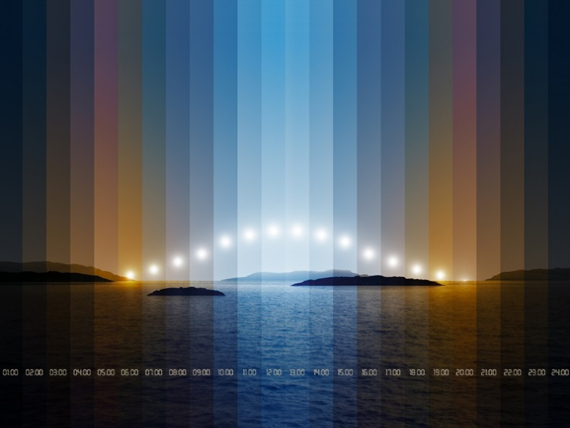

Fig. 1: With the motto “Active Light”, Zumtobel presents a series of new product highlights and future-oriented lighting concepts that provide the right lighting solution for every person, day and night.

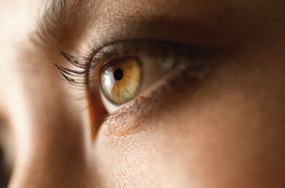
Fig. 2: Active Light supports people on three levels - visual, emotional and biological.

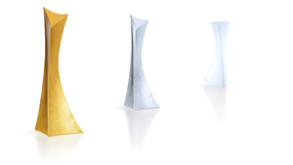
Fig. 3: With the clear aim of delivering optimal visual percepetion, tunableWhite technology makes it possible to seamlessly adjust the colour temperature and light intensity to reflect particular products or exhibits.

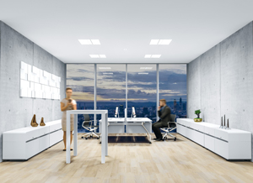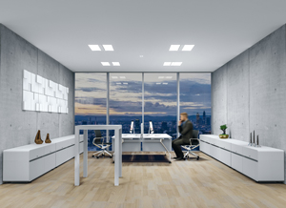
Fig. 4: Active Light provides light in the right intensity, with the right colour and at the right time. To fulfil this promise, this approach is modelled on natural light to support the natural biorhythm, in accordance with the core principles of Human Centric Lighting.
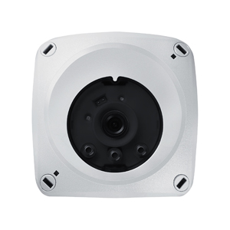
Fig. 5: The ATIVO contrast sensor integrates existing daylight, maintains a specified light level and detects any moving objects. Yet the main benefit is without doubt the freedom to individually define the right-angled detection areas, with the option of up to five zones per sensor.

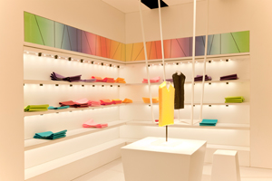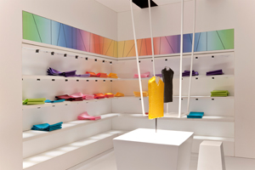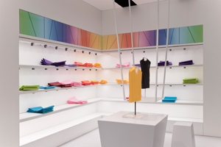
Fig. 6: Active Light with the Limbic® lighting approach in retail applications makes it possible to impeccably showcase brands and products for specific target groups.

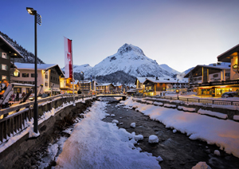
Fig. 7: With SUPERSYSTEM outdoor, Zumtobel has developed a new LED luminaire family that offers accentuating, space-defining LED lighting for outdoor spaces.

Press contact:
Zumtobel Lighting GmbH  Kiki McGowan  Head of Brand Communications  Schweizer Strasse 30  6850 Dornbirn  Phone: +43 5572 309 1303  kiki.mcgowan@zumtobelgroup.com  www.zumtobel.com | Zumtobel Lighting GmbH  Andreas Reimann  Brand PR Manager  Schweizer Strasse 30  6850 Dornbirn  Phone: +43 5572 390 26522  andreas.reimann@zumtobelgroup.com  www.zumtobel.com
Zumtobel Group  Jennifer Sewell  Marketing Communications Manager  Chiltern Park, Chiltern Hill  Chalfont St Peter, Buckinghamshire SL9 9FG  United Kingdom  Phone: +44 0 7785 232 294  jennifer.sewell@zumtobelgroup.com  www.zumtobel.com | Zumtobel Lighting Inc.  Karianna Haasch  Marketing Manager Americas  Zumtobel Lighting US  3300 Route 9W  Highland, NY 12528-2630  Phone: +1 845-691-6262 - 7611  karianna.haasch@zumtobelgroup.com  www.zumtobel.us

About Zumtobel
As a leader in innovation, Zumtobel develops sustainable lighting solutions tailored to the needs of people in their respective applications. With a comprehensive portfolio of high-quality luminaires and intelligent lighting management systems, the Austrian company provides optimum indoor and exterior products for working and living spaces - the right light for every activity at any time of day. The applications office, education, presentation and retail, hotel and wellness, health, art and culture and industry are now perfectly complemented with portfolios for living and outdoor areas. Zumtobel is a brand of Zumtobel Group AG with its head office in Dornbirn, Vorarlberg (Austria).
Zumtobel. The Light.

