Press release

Design highlight: CAELA by Zumtobel and GRAFT Architects
The CAELA LED luminaire range turns the lighting system into a design item: in close cooperation with GRAFT Architects, Zumtobel has developed a decorative task luminaire that impressively combines elegance and lightness. However, it is not only its sophisticated appearance but also its modular design and versatility that make CAELA especially attractive. Thanks to maximum efficiency and innovative light distribution, the luminaire range is suited to solve a vast variety of lighting tasks.
Dornbirn, November 2015 – The new CAELA LED luminaire range by Zumtobel and GRAFT Architects meets the highest demands as a decorative task luminaire both in terms of functional lighting and attractive design. The design philosophy of the luminaire is based on the desire to elevate not only the luminaire itself but also the effects of light in a room to a design item. With CAELA this has been achieved in an impressive way. The LED luminaire range boasts an innovative, flat design and two different kinds of light distribution.
As a wall-mounted, ceiling-mounted and pendant luminaire, CAELA appears extremely slim and elegant, with a maximum depth of 55 mm. The pared-down stylistic idiom is emphasised by the diffuse cover. CAELA is available as a round or square luminaire with a diameter or side length of 330 mm and 430 mm and in the colours white, matt silver, copper, brass, matt grey and black. In these versions, CAELA serves to decorate corridors and entrance areas in administration buildings as well as restaurants, offices and private domestic areas. The luminaire's modular design is continued in the choice of switchable and dimmable models, with a luminous flux of 1000 and 1500 lm, as well as its light distribution: in addition to symmetrical standard light distribution, the square version of the wall-mounted luminaire also features innovative asymmetrical light distribution specifically geared to meet the lighting requirements in corridors and staircases. The light is precisely directed onto the floor, thus avoiding spill light towards the ceiling while the floors and walls are lit uniformly.
For additional energy efficiency, the CAELA LED luminaire can easily be integrated into a lighting management system. Emergency lighting can be implemented with this luminaire in the same manner. Therefore, CAELA is more than a decorative highlight; it also meets the highest demands on integral lighting solutions: it can be intelligently and individually adjusted to various lighting tasks, boasts maximum efficiency, and gives architects and lighting designers creative scope corresponding to the zeitgeist.

CAELA facts & figures
- Decorative LED task luminaire meeting the highest design demands
- Round or square design with a diameter/side length of 330 mm or 430 mm
- Square design (wall-mounted luminaire) with asymmetrical light distribution
- Slim, elegant housing (depth: < 55 mm) available in six colours
- Installation: pendant, wall-mounted and ceiling-mounted
- Optionally available with presence detector
- Luminous flux: 1000 lm or 1500 lm
- Service life: 50,000 hours

Captions:

(Photo credits: Zumtobel)
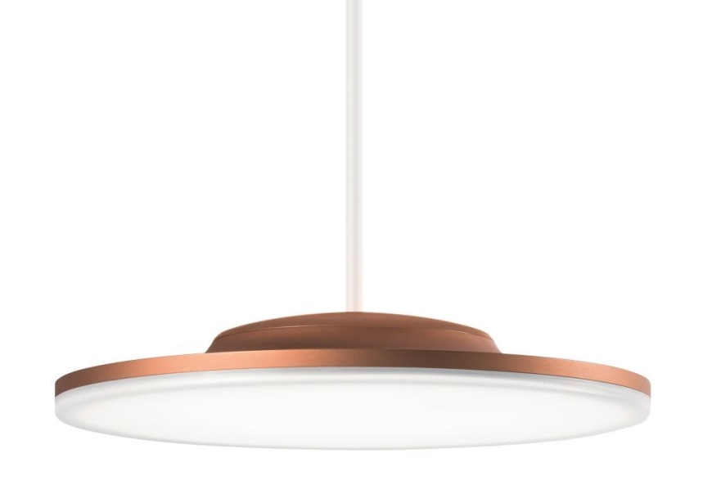
Fig. 1: CAELA – as pendant luminaire

Fig. 2: CAELA – as square or round wall- or ceiling-mounted luminaire

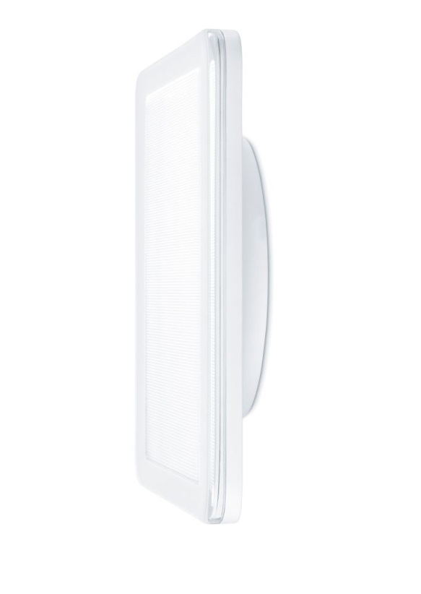
Fig. 3: The CAELA LED luminaire range boasts an innovative, flat design and two different kinds of light distribution.

Press contact:
Zumtobel Lighting GmbH
Sophie Moser
Head of Brand Communications
Schweizer Strasse 30
6850 Dornbirn
Austria

Tel: +43 5572 390 26527
Mobil: +43 664 80892 3074
press@zumtobel.com

www.zumtobel.com

Sales contact:
Zumtobel Lighting Ltd.  Chiltern Park  Chiltern Hill, Chalfont St Peter  Buckinghamshire SL9 9FG  United Kingdom  Tel: +44 1753 482 650  Fax: +44 1753 480 350  uksales@zumtobel.com  www.zumtobel.co.uk | Zumtobel Lighting Inc.  3300 Route 9  Highland , NY 12528  United States  Tel: +1 845 691 6262  Fax: +1 845 691 6289  zli.us@zumtobelgroup.com  www.zumtobel.us

For further contact details in further sales regions please visit: http://www.zumtobel.com/com-en/contact.html

About Zumtobel
Zumtobel, a leading international supplier of integral lighting solutions, enables people to experience the interplay of light and architecture. As a leader in innovation, Zumtobel provides a comprehensive range of high-quality luminaires and lighting management systems for professional interior lighting in the areas of offices, education, presentation & retail, hotel & wellness, health, art & culture as well as industry. Zumtobel is a brand of Zumtobel Group AG with its head office in Dornbirn, Vorarlberg (Austria).

Zumtobel. The Light.

