Press release

New headquarters of Leica Camera AG now presented in the best light
Zumtobel lighting solution perfectly blends with the interior design

The new administrative and manufacturing headquarters of Leica Camera AG serve as a shining monument of the German company with its long-standing tradition. For the new company head office, Zumtobel has developed a lighting solution that meets both the individual requirements of the new building complex and the needs of various users.

Dornbirn, October 2014 – In spring 2014, Leica Camera AG moved to its new ultramodern manufacturing and administrative headquarters in Wetzlar, the town where the company was founded. Designed by Frankfurt-based architects Gruber + Kleine-Kraneburg, the Leitz Park accommodates not only the Leica Camera AG complex, but also two other corporate buildings and a detached coffeehouse. Many areas of the new headquarters are publicly accessible, allowing visitors and customers insights into the history of Leica Camera AG and its products. Works by Leica photographers are presented here as well. In addition to the administrative headquarters, the complex also accommodates a museum, an art gallery, a Leica flagship store, a restaurant and manufacturing areas that are visible from outside. The individual building units are connected to each other on the ground floor, which is structurally emphasised by a surrounding glass façade that is curved in some places. At night, it keeps the building units together like a luminous ribbon reminiscent of a photographic film reel. With its clear stylistic idiom and unobtrusive design, the lighting solution implemented by Zumtobel in close coordination with the lighting designers from hpi Himmen and Lichtvision supports the self-confident yet discreet architectural structure of the Leitz Park, creating in every area an atmosphere in line with the user requirements of both visitors and staff.

The project involved the most varied specifications: first of all, the lighting solution was supposed to completely blend into the interior design, subtly enhancing the respective room's character. Besides, the requirements of various users had to be met. For instance, a perfect office environment was to be created for the staff working in the administrative complex. The areas open to the public required an inviting atmosphere to welcome visitors. In particular the art gallery made high demands on the luminaires' flexibility, since the exhibits on display in the temporary exhibitions shown here are constantly changing. An additional requirement specified by Leica was that it should be possible to control and dim all built-in luminaires via an EIB/KNX system integrated in the building management system.
For the headquarters' data centre, Zumtobel used CLARIS II pendant luminaires, which are characterised by reduced minimalism, linear design and a geometrical design language. Combined with innovative louvre technology, they provide for perfect lighting. In addition, the precise design of the groove of the indirect reflector ensures homogeneous illumination of the ceiling.
In secondary areas and corridors of the Leica building complex, LINARIA surface-mounted luminaires facilitate spatial orientation. The clear lines of the batten luminaires provide gentle and uniform illumination, creating a room ambience that is perceived as very pleasant. Only three centimetres in height, the smallest of the DALI-compatible batten luminaires boasts an extremely complex design.

Two models of the PANOS infinity LED luminaire range round off the lighting solution for the new Leica headquarters: they were installed as downlights in corridors and as wallwashers in customer areas and themed areas as well as in the coffeehouse. The mostly uniform colour temperature forms a visual bracket. While Zumtobel used downlights featuring a colour temperature of 3000 K for general lighting, the wallwashers required a colour temperature of 4000 K due to incident daylight. High functionality and flexibility was the decisive criterion for selecting the LED luminaires of the PANOS infinity range: “The Panos luminaires could not fail to impress us thanks to their quality, on the one hand: their high colour rendering, uniform light distribution and advanced LED technology allowed us to consistently meet the diverse requirements of the project. At the same time, the restrained stylistic idiom of the luminaire design enhances the building's architectural structures,” explains Isabel Sternkopf from Lichtvision. In addition, the wallwashers allow high-precision direction of light: the light is directed precisely where it is required by the exhibit or the application. The high energy efficiency of an LED solution, too, speaks for itself: by using LED luminaires, at least 40 percent of energy can be saved, as compared to a conventional luminaire system.

Facts & figures on the Zumtobel products used
CLARIS II | Minimalist surface-mounted and pendant luminaires; angular, stepped housing made of aluminium extrusion; dimmable
LINARIA | Batten luminaire with open light distribution made of high-grade aluminium, powder-coated in silver aluminium; surface and pendant mounting possible; luminaire fitted with halogen-free wiring; dimmable; include DALI-controllable electronic ballast
PANOS infinity | LED downlight with 3000 K  LED wallwasher with 4000 K

Captions:

(Photo credits: Zumtobel)

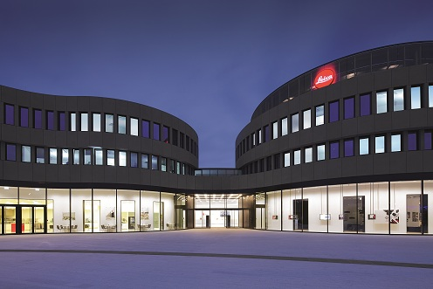
Fig. 1: For the new company headquarters of Leica Camera AG, Zumtobel has developed a lighting solution that meets both the individual requirements of the new building complex and the needs of various users.

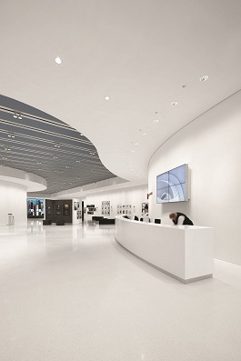

Fig. 2: With its clear stylistic idiom and unobtrusive design, the lighting solution implemented by Zumtobel in close coordination with the lighting designers from hpi Himmen and Lichtvision supports the self-confident yet discreet architectural structure of the Leitz Park.

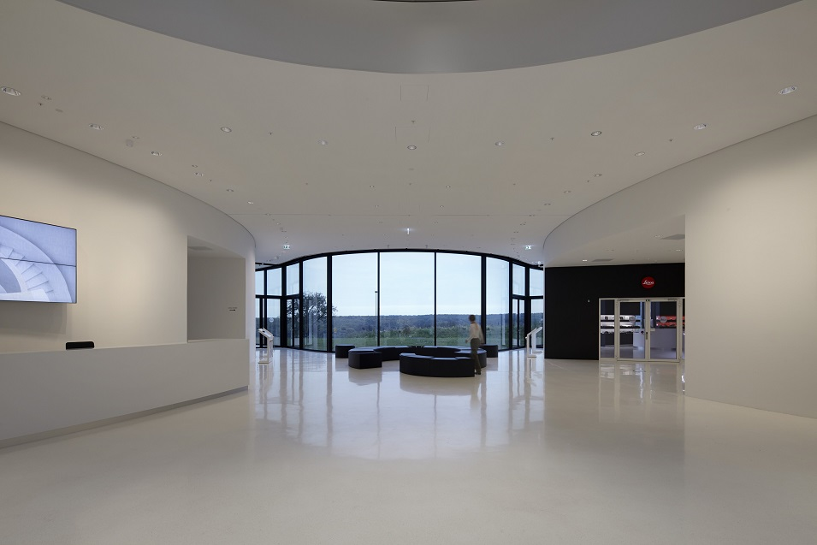

Fig. 3: The lighting solution was supposed to completely blend into the interior design, subtly enhancing the room's character.

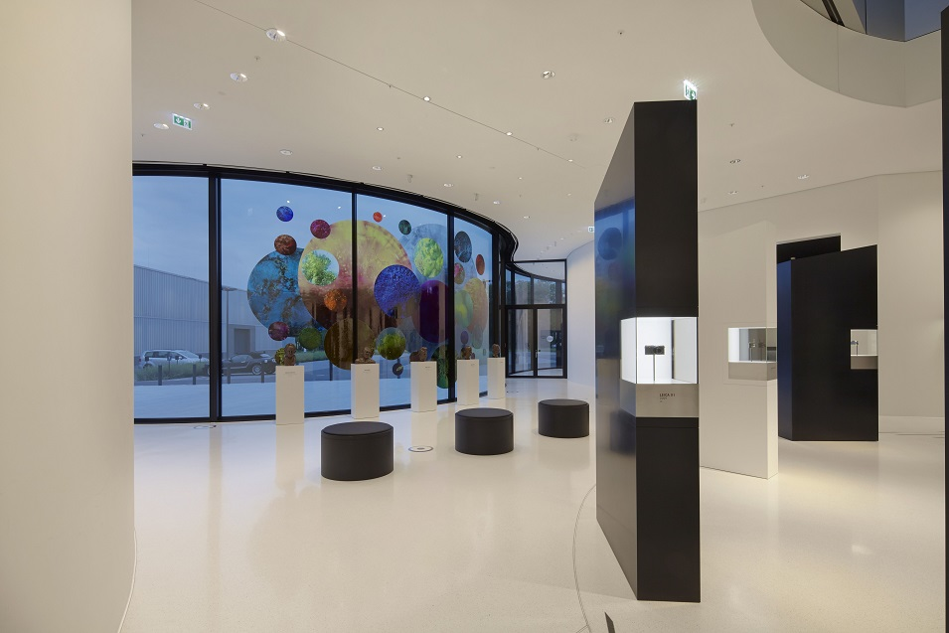

Fig. 4: While Zumtobel used PANOS infinity downlights featuring a colour temperature of 3000 K for general lighting, the wallwashers required a colour temperature of 4000 K due to incident daylight.

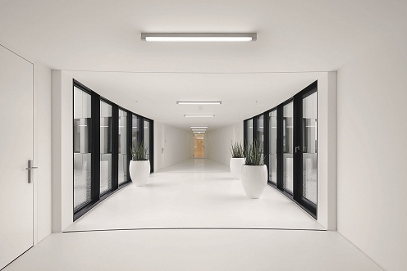

Fig. 5: In secondary areas and corridors of the Leica building complex, LINARIA surface-mounted luminaires facilitate spatial orientation.

Press contact:
Zumtobel Lighting GmbH  Sophie Moser  PR Manager  Schweizer Strasse 30  A-6851 Dornbirn  Tel.: +43-5572-390-26527  Mobile; +43-664-80892-3074  e-mail: sophie.moser@zumtobelgroup.com  www.zumtobel.com | ZG Zumtobel Lighting GmbH  Daniel Lechner  Director Marketing Austria  Donau-City-Strasse 1  A-1220 Vienna  Tel +43 (1) 258 26 01 82875  Fax +43 (1) 258 26 01 982875  E-mail daniel.lechner@zumtobelgroup.com  www.zumtobel.at

About Zumtobel
Zumtobel, a leading international supplier of integral lighting solutions, enables people to experience the interplay of light and architecture. As a leader in innovation, Zumtobel provides a comprehensive range of high-quality luminaires and lighting management systems for professional interior lighting in the areas of offices, education, presentation & retail, hotel & wellness, health, art & culture as well as industry. Zumtobel is a brand of Zumtobel AG with its head office in Dornbirn, Vorarlberg (Austria).
Zumtobel. The Light.

