Press release

Dornbirn, July 2012

**More than 80% of energy saved thanks to LED light lines used for corridor lighting**

The Public Works Department of Zurich's City Council conducted a pilot measurement project together with Eteam GmbH and Zumtobel. The lighting in two identical corridors in the Zurich-based Werd Administrative Centre was investigated to establish the potential energy savings that can be obtained using LEDs and optimised presence-based control. The result at the end of the four-month measurement period: LED lighting operated in the most energy-efficient mode can save more than 80% of energy, compared to conventional fluorescent lamp technology.

For the pilot project, one of the two corridors remained unchanged: the conventional fluorescent lamps were switched off by presence detectors as soon as there had been no one in the corridor for more than ten minutes. The other corridor was fitted with innovative Slotlight LED luminaires by Zumtobel. In addition, the switch-off delay of the presence detectors was reduced down to one minute in several stages. In the case of LEDs, frequent switching or dimming has no adverse effects on lighting comfort and causes no wear. The measured power consumption of the LED solution with optimised presence monitoring was 81% less than that of comparable luminaires fitted with fluorescent lamps.

“The result of the pilot project shows that LED technology combined with appropriate lighting control allows for huge potential savings and is by far superior to current standard corridor lighting concepts that are also deemed to be energy-efficient”, explains Daniel Cathomen, Zumtobel Marketing Manager Switzerland, further adding: “A combination of appropriate light sources and a finely tuned lighting management system therefore creates innovative, energy-optimised, future-proof lighting solutions that are highly acceptable to users and have short payback periods.”

**Zumtobel. The Light.**

**Brief profile**

Zumtobel is a leading international supplier of integral lighting solutions that enable people to experience the interplay of light and architecture. As a leader in innovation, the luminaire manufacturer provides a comprehensive range of high-quality luminaires and lighting management systems for the most varied application areas of professional interior lighting – including offices and educational facilities, presentation and retail, hotels and wellness, health and care, art and culture as well as industry and engineering. Zumtobel is a brand of the Zumtobel group with its head office in Dornbirn, Vorarlberg (Austria).

For more information, please contact:



Zumtobel Lighting GmbH Zumtobel Lighting GmbH

Nikolaus Johannson Britta Maier

Head of Brand Communication PR Manager

Schweizer Strasse 30 Schweizer Strasse 30

A-6850 Dornbirn A-6850 Dornbirn

Tel. +43-5572-390-26427 Tel. +43-5572-390-26527

Fax +43-5572-390-926427 Fax +43-5572-390-926587

[nikolaus.johannson@zumtobel.com](mailto:nikolaus.johannson@zumtobel.com) [britta.maier@zumtobel.com](mailto:britta.maier@zumtobel.com)

[www.zumtobel.com](http://www.zumtobel.com/) [www.zumtobel.com](http://www.zumtobel.com/)

**Captions**

(Copyright: Zumtobel)

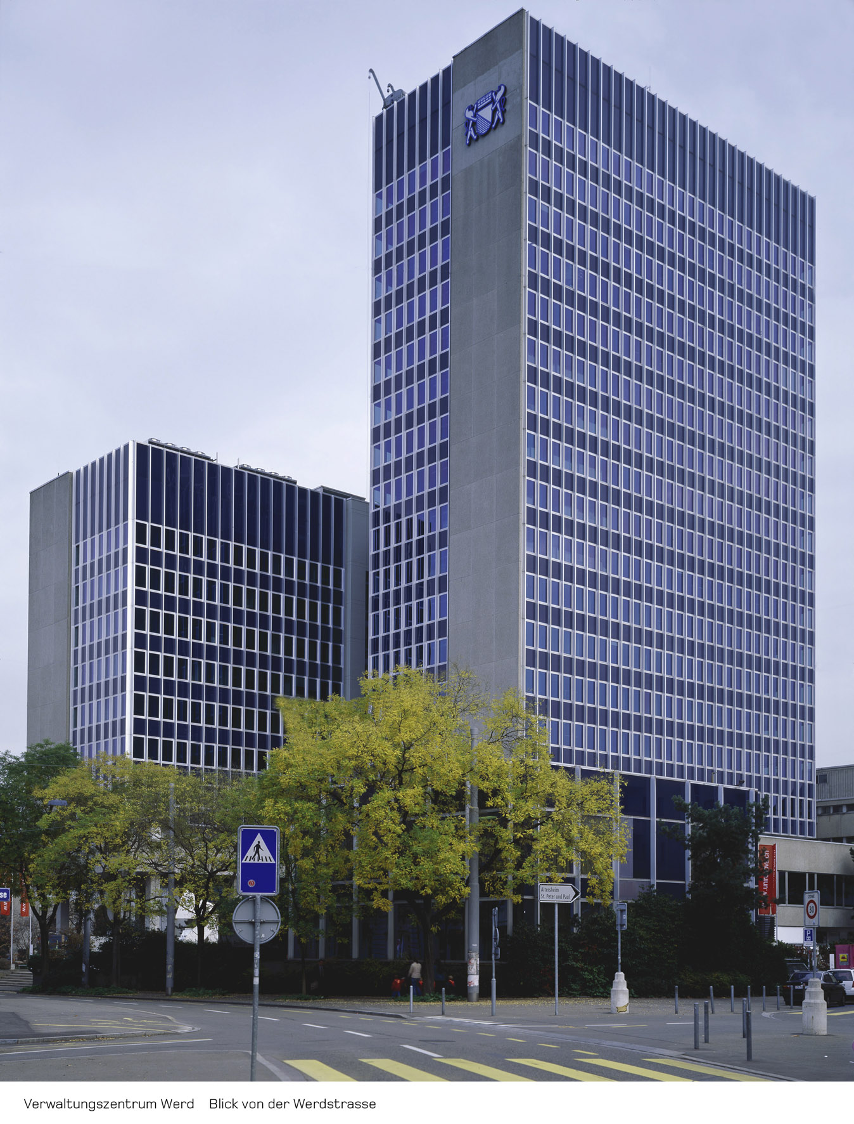

Caption 1: 80% di energia risparmiata con le linee LED in corridoio

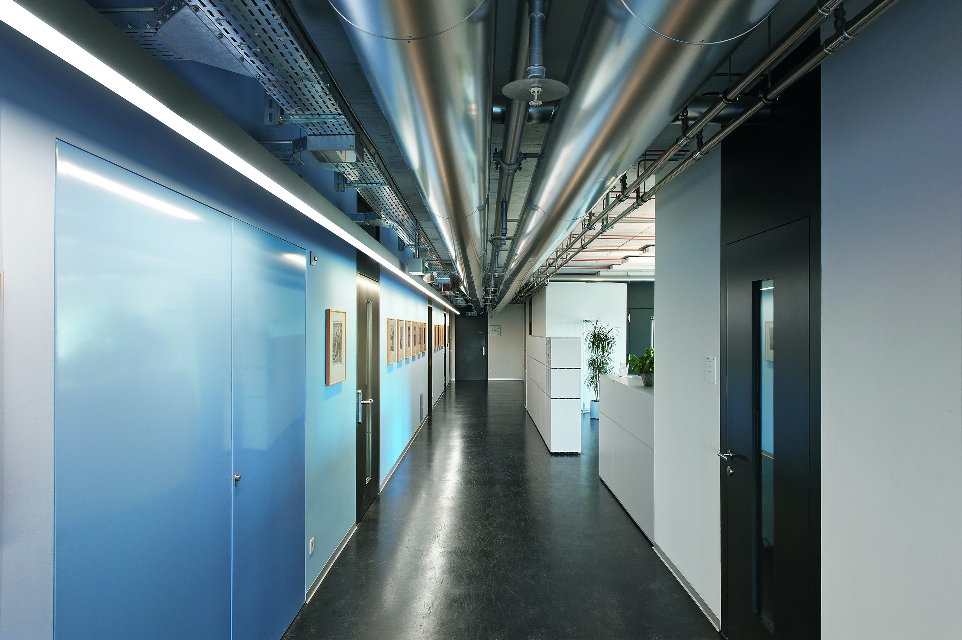

Caption 2: One of the two corridors remained unchanged, the other corridor was fitted with innovative Slotlight LED luminaires by Zumtobel