Press information

Zumtobel honoured with three red dot awards. SUPERSYSTEM II receives the highest “best of the best” quality seal.
Design solutions from Zumtobel have been commended three times by the expert jury at the red dot awards 2016. Special recognition was reserved for the LED light tool SUPERSYSTEM II, which has been awarded the highest accolade for ground-breaking design excellence, the coveted red dot “best of the best” title. In addition, jurors were markedly impressed by the creative merits of the SUPERSYSTEM outdoor LED lighting system and the CAELA decorative LED luminaire.
Dornbirn, June 2016 – Lighting solutions from Zumtobel epitomise sophisticated design that is honed to reflect the specific needs of users. Further multiple red dot awards demonstrate the high solutions competence and innovative strength of the Austrian lighting manufacturer. “The red dot award 2016 recognises our efforts to develop innovative lighting concepts for our customers, which impress through a blend of excellent lighting quality, aesthetic design and significant added value,” explains Daniel Lechner, Marketing Director Zumtobel. “With SUPERSYSTEM II we have extended the success story of the product family into the second generation. The high-quality design and adaptability of this light tool offer users enormous freedom when it comes to planning.”
SUPERSYSTEM II: Minimalism with a major impact
Maximum flexibility and a minimalist design language characterise the innovative SUPERSYSTEM LED lighting system from Zumtobel. The product family has been expanded with the launch of the second generation. The latest LED technology facilitates a high degree of miniaturisation and outstanding lighting quality. The result is a modular system on a low voltage track base for a wide variety of different tasks in the fields of shop and retail and museums and galleries, as well as in hotels and restaurants, conference rooms and private residential areas. This modular lighting system supports full flexibility when it comes to planning, with a choice of three spotlight sizes, a framing spotlight for accent lighting, a linear luminaire for horizontal requirements and a wall washer for homogenous vertical illumination.
SUPERSYSTEM outdoor: The future of outdoor lighting
Zumtobel has used the development of the SUPERSYSTEM outdoor LED luminaire to pioneer a completely new approach to the task-specific illumination of roads, squares, streets and facades. Targeted space-defining illumination of outdoor areas is now also possible thanks to modules featuring a series of beam patterns based on the SUPERSYSTEM range for interior lighting. A key aspect of the product family is excellent adaptability. Interchangeable components can be combined as required thanks to the highly compatible modular system and a consistent design language.
CAELA: A design highlight from Zumtobel and GRAFT Architects
The new CAELA LED luminaire family from Zumtobel and GRAFT Architects meets the highest demands that can be placed on a decorative task luminaire, both in terms of functional lighting and attractive design. The core philosophy of the product is based on a desire to specifically showcase the lighting effect in the space as a discernible design item. An innovative, slim design and two different kinds of light distribution define this LED luminaire range. Alongside the standard symmetrical light distribution, a square version of the wall-mounted luminaire features an innovative asymmetrical distribution that has been optimised to meet the lighting requirements in corridors and staircases. CAELA appears extremely slim and elegant as a wall-mounted, ceiling-mounted or pendant luminaire, adding a decorative touch to corridors and entrance areas in offices and restaurants, as well as in private residential areas.
The red dot design award
The red dot design award is regarded as one of the most prestigious international design competitions, with the distinctive red dot establishing itself worldwide as a highly sought-after quality seal. This year saw manufacturers, designers and architects from 57 countries submit a total of 5214 products for the competition. The awards will be presented at the red dot gala on 4. July 2016, when international guests from the worlds of design, business, politics and media will gather in the Aalto Theatre in the German city of Essen. The winning products can then be seen as part of a four-week exhibition at the red dot design museum. With around 2000 exhibits displayed over 4000 square metres, the museum in Essen now houses one of the largest collections of contemporary design products in the world.

Photo captions:

(Photo credits: Zumtobel)
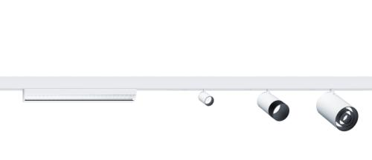

Photo 1: The highly compatible modular SUPERSYSTEM II gives architects and lighting designers a completely new level of design freedom.

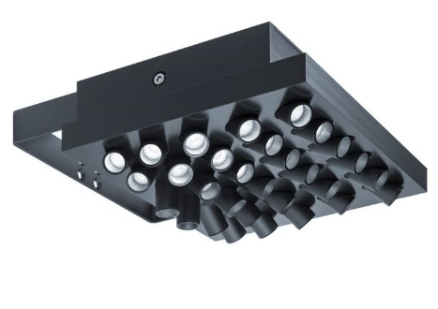

Photo 2: Zumtobel has pioneered a completely new approach to the task-specific illumination of roads, squares, streets and facades with SUPERSYSTEM outdoor.

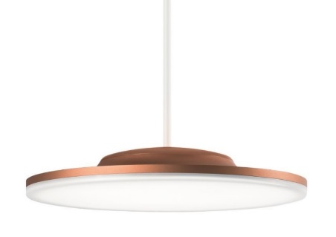

Photo 3: The CAELA LED luminaire family is characterised by an innovative, slim design and two different kinds of light distribution - seen here as a pendant version.

Photo 4: Official logo of the red dot award 2016: best of the best

Photo 5: Official logo of the red dot award 2016

Photo 6: Daniel Lechner, Director Marketing Zumtobel

Press contact:
Zumtobel Lighting GmbH  Andreas Reimann  Brand PR Manager  Schweizer Strasse 30  6850 Dornbirn  Austria  Phone: +43 5572 390 26522  press.zumtobel@zumtobelgroup.com  www.zumtobel.com | Zumtobel Group  Jennifer Sewell  Marketing Communications Manager  Chiltern Park, Chiltern Hill  Chalfont St Peter, Buckinghamshire SL9 9FG  United Kingdom  Phone: +44 0 7785 232 294  jennifer.sewell@zumtobelgroup.com  www.zumtobel.com
Zumtobel Lighting Inc.
Karianna Haasch
Marketing Manager Americas
Zumtobel Lighting US
3300 Route 9W
Highland, NY 12528
Phone: +1 845-691-6262 - 7611
karianna.haasch@zumtobelgroup.com
www.zumtobel.us

About Zumtobel
As a leader in innovation, Zumtobel develops sustainable lighting solutions tailored to the needs of people in their respective applications. With a comprehensive portfolio of high-quality luminaires and intelligent lighting management systems, the Austrian company provides optimum indoor and exterior products for working and living spaces - the right light for every activity at any time of day. The applications office, education, presentation and retail, hotel and wellness, health, art and culture and industry are now perfectly complemented with portfolios for living and outdoor areas. Zumtobel is a brand of Zumtobel Group AG with its head office in Dornbirn, Vorarlberg (Austria).
Zumtobel. The Light.

