Press Release

NIGHTSIGHT creates a world of lighting experiences in a night-time cityscape
With the modular LED outdoor lighting system NIGHTSIGHT, Zumtobel offers the opportunity to brighten up outdoor areas and buildings with well thought-out lighting concepts adjusted to suit the needs of people. The comprehensive portfolio allows lighting planners and architects to plan a lighting solution in a universal manner and opens up a whole new realm of creative freedom for them.
Dornbirn, March 2016 – Modern LED outdoor lighting today takes into account all visual levels in an urban space and is not just limited to a norm-standard level of illuminance to light up those elements of the nocturnal cityscape in focus. Rather, this is about placing emphasis on the needs of people in living spaces at night. It's therefore worth brightening up urban spaces with spherical light components to create centres for human communication, creating visual points of attraction, and improving three-dimensional awareness. Moreover, special architectural features should be highlighted and complex space structures brought to life. This increases recognition value for a region and creates reliable guidance and orientation, even at night. In this way, security and well-being are significantly improved by lighting quality – always without wasting resources or increasing light pollution.
The starting point for such lighting design is always the natural nocturnal situation, the darkness from which the lighting designers design the optimal lighting solution step by step – with only as much light as is necessary. NIGHTSIGHT from Zumtobel as a lighting instrument is predestined to overcome these new challenges For the development of the modular lighting tool, Zumtobel working closely with the designers of Ben van Berkel at UNStudio. The aim here was to create a unique lighting environment, with the help of an adaptive lighting system, which increases social value by taking into consideration human activity and needs in the different phases of the night, and at the same time maintaining the balance between artificial light and darkness.
With NIGHTSIGHT, the experts succeeded in designing a uniform modular product family with a unique look for various applications in urban lighting. The new application encompasses four different formats in a clear, continuous design with a comprehensive portfolio of looks and installation options. In order to both illuminate vertical and horizontal surfaces homogeneously and to set targeted accents, Zumtobel uses two different types of luminaires: perfected for illuminating façades or highlighting architectural details, the projector luminaire with its "darkBeam" look, with LED light points arranged in a special sunken honeycomb structure with their projection lenses meaning side-on glare from the light source is minimised, as are glare effects. Attention is drawn to highlighted objects whilst remaining in the background.
The Area luminaire with a "softGlow" look, on the other hand, improves the lighting of spaces and paths above all. Targeted lighting angles ensure ideal visual comfort by reducing the brightness contrast between the LED light points and the environment. The additional vertical lighting component ultimately offers visual guidances and makes it easier for the eye to adjust the brightness level when entering the illuminated area, thereby reducing sensitivity to glare.
With NIGHTSIGHT, Zumtobel offers lighting designers not just a lighting instrument with a convincing lighting effect and consistent design however, as the outdoor lighting system also makes a mark with its simple installation and maintenance. Installation is particularly easy thanks to the Plug&Play connection. The light heads of the individual LED modules can also be easily adjusted to almost any angle. Moreover, various colour temperatures are also available: options with 3000 K and 4000 K place both the historical old town and a modern skyline in the right light.
Thanks to the targeted use of light and shadow, bright and dark tones, as well as differing light levels, NIGHTSIGHT manages to improve perception of a nocturnal cityscape, highlights special architectural features , creates recognition value, and models spaces – always in harmony with the environment. In this way, both visual comfort and quality of life in an urban outdoor space are improved, whilst the energy consumption of a lighting solution is reduced at the same time.
NIGHTSIGHT will be available from Autumn 2016.

Facts and figures for NIGHTSIGHT
- Modular LED product family for multi-faceted urban applications
- Luminous flux: 600 – 7900 lm
- Luminaire efficiency factor: 80-100 lm/W @ 4000K
- Colour temperature: 3000 K or 4000 K, Ra > 80
- Light distribution: 5 projection types, 6 area types (composite beam look)
- Optics: Lens-grid combo and comfort lighting function
- High IP rating: min. 65
- Installation: mast, wall, floor, ceiling – completely rotatable or fixed
- Control: dimmable for DALI/LITECOM or on-board
- Service life: 100,000 hours

Image captions:

(Photo Credits: Zumtobel)

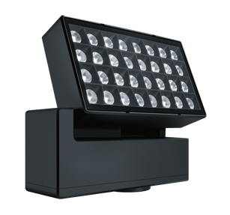

Image 1: The modular NIGHTSIGHT product family include all lighting tools for illuminating both vertical and horizontal surfaces, and for setting targeted accents.

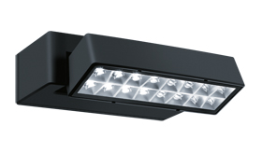
Image 2: The Area luminaire with a "softGlow" look, on the other hand, improve the lighting of spaces and pathways.

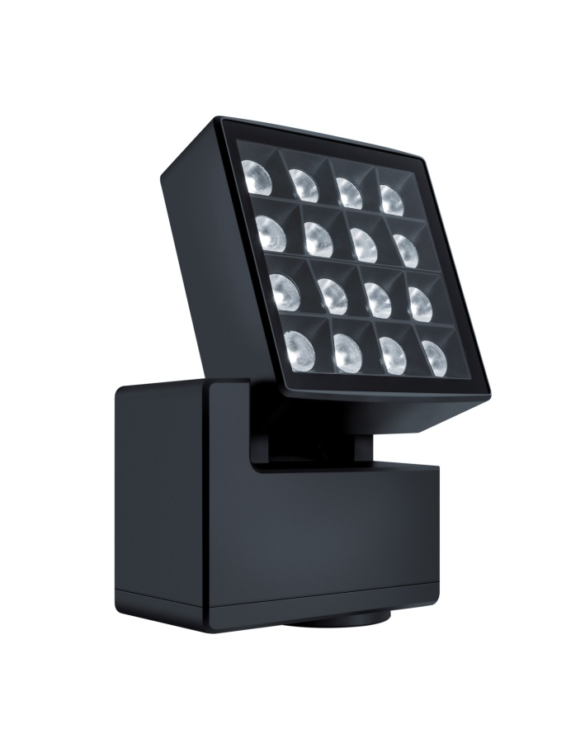
Image 3: Perfected for illuminating façades or highlighting architectural details, the projector luminaire with its "darkBeam" look, with LED light points arranged in a special sunken honeycomb structure with their projection lenses.

Press contact:
Zumtobel Lighting GmbH  Andreas Reimann  Brand PR Manager  Schweizer Strasse 30  6850 Dornbirn  Austria  Phone: +43 5572 390 26522  press@zumtobel.com  www.zumtobel.com | Zumtobel Group  Jennifer Sewell  Marketing Communications Manager  Chiltern Park, Chiltern Hill  Chalfont St Peter, Buckinghamshire SL9 9FG  United Kingdom  Phone: +44 0 7785 232 294  jennifer.sewell@zumtobelgroup.com  www.zumtobel.com
Zumtobel Lighting Inc.
Donna Fischer
Marketing Manager Americas
Zumtobel Lighting US
3300 Route 9W
Highland, NY 12528
Phone: +1 845-691-6262 - 7611
donna.fischer@zumtobelgroup.com
www.zumtobel.us

About Zumtobel
As a leader in innovation, Zumtobel develops sustainable lighting solutions tailored to the needs of people in their respective applications. With a comprehensive portfolio of high-quality luminaires and intelligent lighting management systems, the Austrian company provides optimum indoor and exterior products for working and living spaces - the right light for every activity at any time of day. The applications office, education, presentation and retail, hotel and wellness, health, art and culture and industry are now perfectly complemented with portfolios for living and outdoor areas. Zumtobel is a brand of Zumtobel Group AG with its head office in Dornbirn, Vorarlberg (Austria).
Zumtobel. The Light.

